We are working on 3 areas this year.
Focus 1 - Global Citizenship
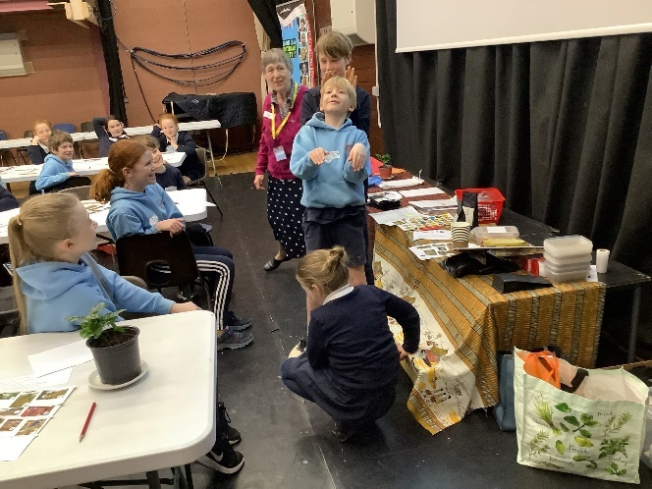
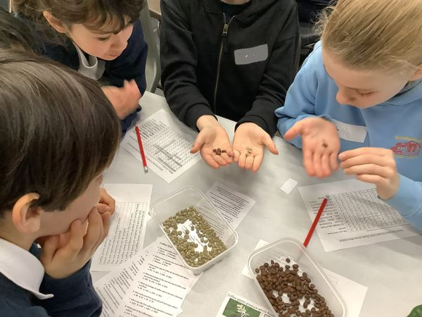
Fairtrade workshop with a local secondary school

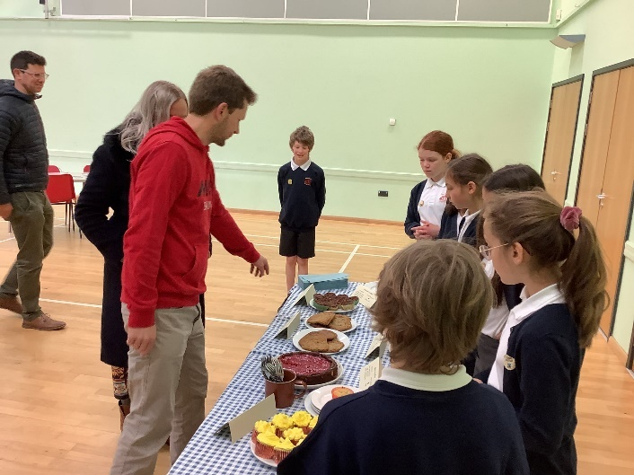
Fairtrade coffee morning organised and run by years 5 and 6.
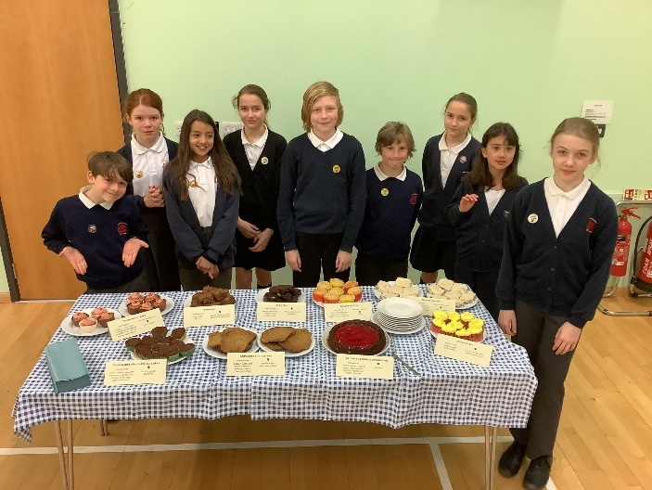
Raising money for global charities
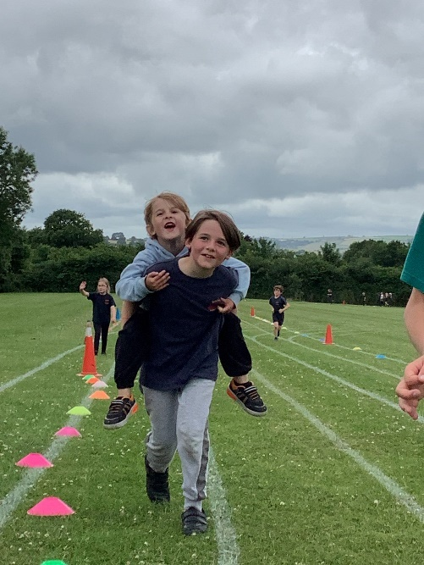
Miles for Refugees (Red Cross)
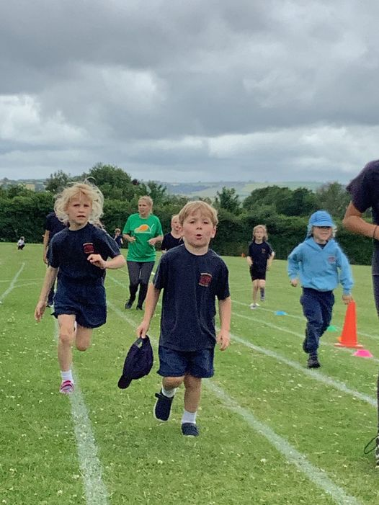
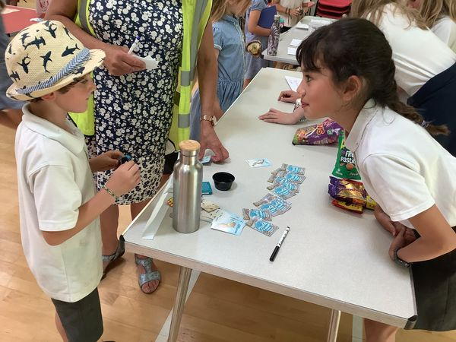
Charity Fair (Shelter Box)
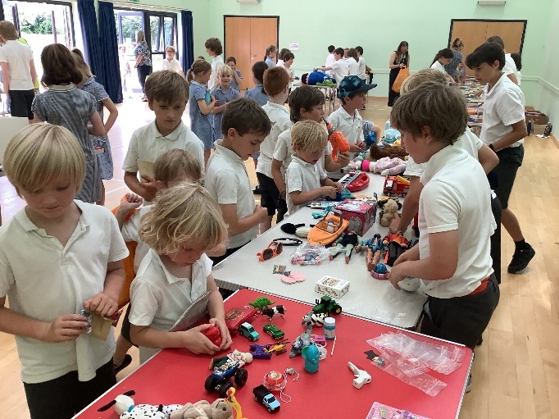
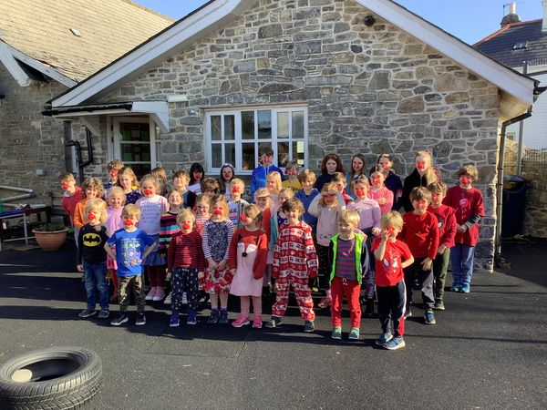
Comic Relief
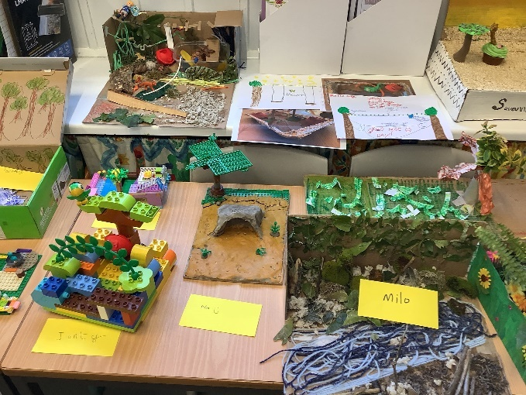
Global Citizenship teaching through the curriculum
Oak class (Y5/6) – In Geography we learnt about flooding in Bangladesh because of climate change. We studied how this affected the people living in the flooded areas and how it changed their lives. We also learnt about a boy called Elhaji from Gambia who had to work shining shoes to support his family. This was caused by climate change. Because of climate change, Banjul’s crops had failed and that was why he was no longer able to go to school. We spent time imagining ourselves in his shoes. In PSHE we learnt about the UN rights of the child and about how some children do not even have the most basic rights.
Sycamore class (Y3/4) – In Geography we learnt about Earthquakes. We found out that how poor your country is has a bigger impact on the death rate after an Earthquake than the magnitude. An Earthquake in Chile had a higher magnitude than one in Haiti but there were far more fatalities in Haiti. This raised lots of discussion. In a different Geography unit we learnt about Sunita from Nepal who had to travel long distances to fetch wood for cooking. A solar cooker given to her transformed her life. In PSHE we learnt about the rights of the child. We felt a lot of empathy for children loving in places where these rights were not respected.

Willow class (Y1/2)
What is the geography of where I live? Case study on Wembury Beach as part of our Seaside topic. The children explored how people affect the beach at Wembury, revisiting the idea of plastic pollution. They designed another persuasive poster about stopping this and reducing waste on beaches in Devon. They had a parent marine biologist into class to discuss Wembury Beach and the significance of pollution in more depth.

Focus 2 - Marine
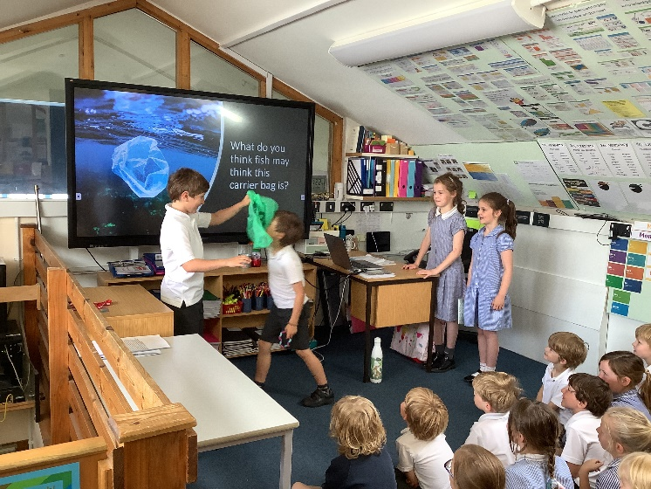
Marine assembly organised and delivered by eco committee

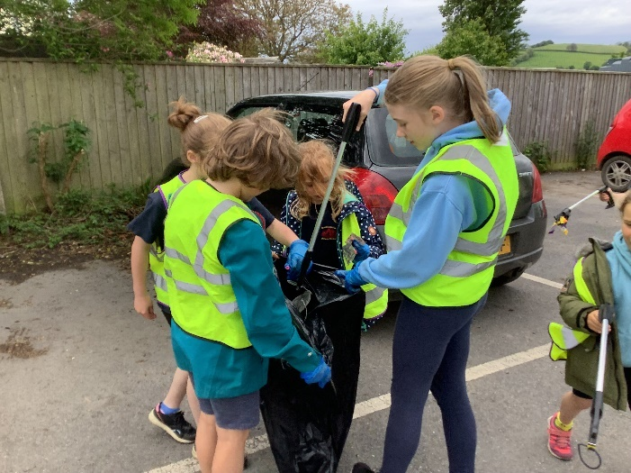
Litter pick in the village
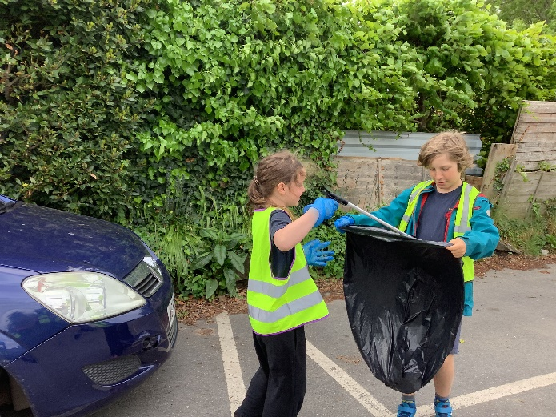

Beach litter picks
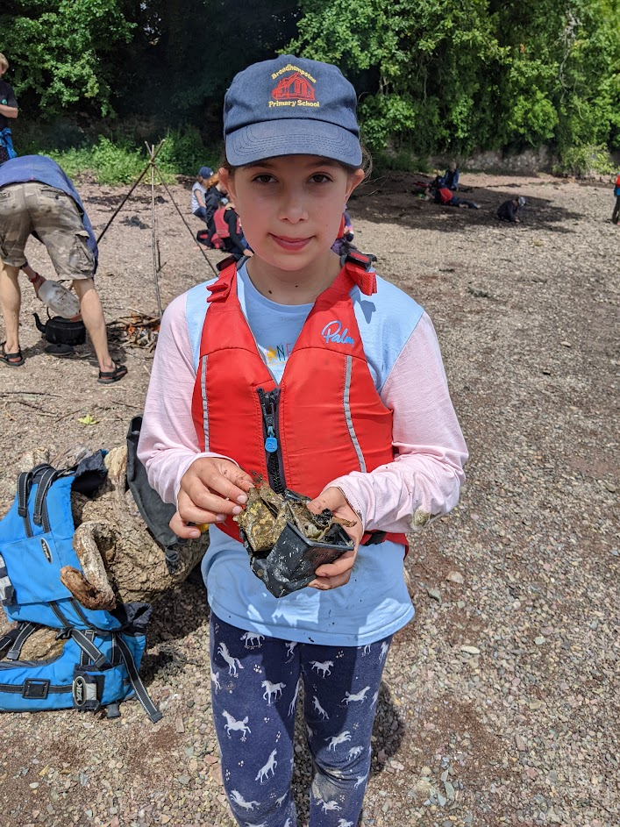
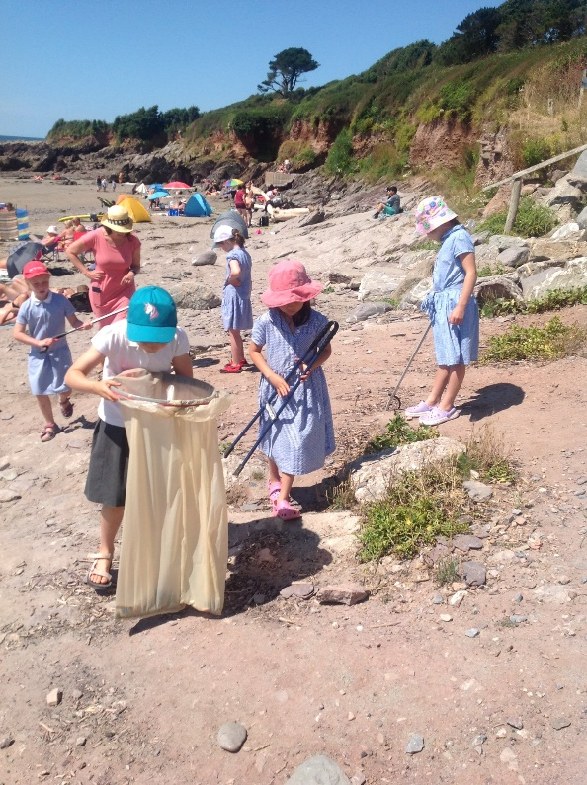

Focus 3 - Waste
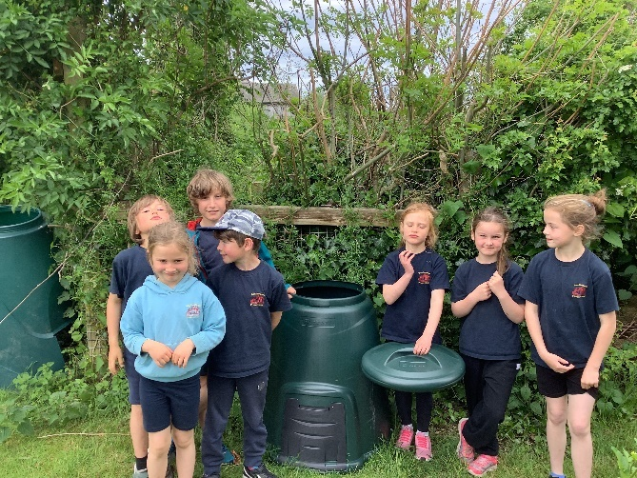
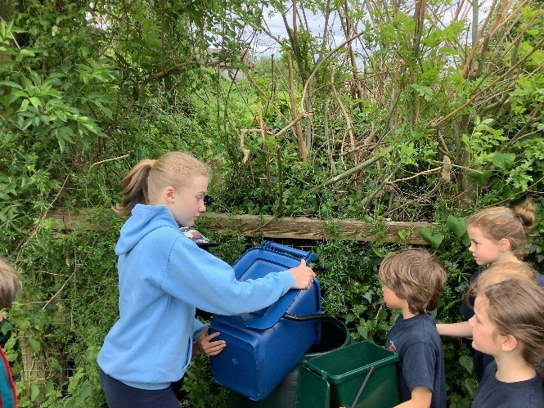
Composting

Hard to recycle items we have collected and will deliver to recycling centre.

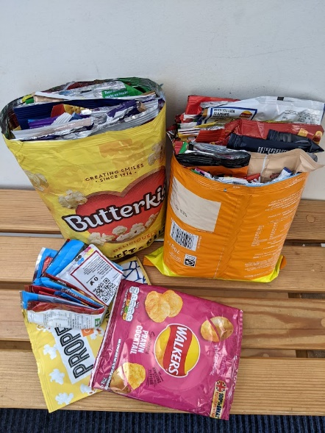
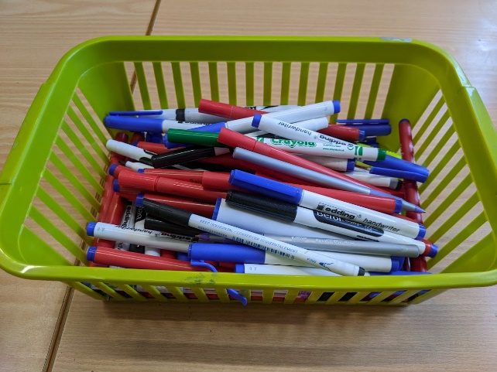

Class paper recycling bins
