Broadhempston Village Primary School
History Curriculum Plan
Our curriculum statements are designed to be used as a supportive tool to plan teaching and learning across our school. The key skills are derived from the National Curriculum and spilt into individual year groups to support a progressive approach and our mixed age classes.
The study of history involves engaging pupils in investigating questions about people and events in the past in order to enable them to better understand their lives today and for a future as more informed and enlightened citizens. Through the study of history pupils also develop a wide range of critical thinking skills, which enable them to understand the contested nature of knowledge and to distinguish between ‘fact’ and subjectivity when it comes to reaching conclusions and making judgements about the past. With this in mind, at Broadhempston, we are proud of our History Curriculum which is:
- Aspirational: Our high-expectations in History teaching and learning cultivates their natural curiosity about the past, enabling our children to fulfil their individual potential and appreciate the value of History as a subject in the 21st century.
- Engaging: Our children develop their historical perspective through enquiry-based learning. The 2nd-order concepts of ‘continuity & change’, ‘cause & consequence’, ‘similarity & difference’ and ‘significance’ underpin these, with children asking increasingly nuanced questions - exploring how the past is constructed from a range of sources, appreciating why interpretations of history vary and understanding how knowledge of the past is constructed by historians.
- Logical, Broad and Balanced: Learning and enquiries have been purposefully selected to reflect a mixture of local, national and global history and have been sequenced to support chronological understanding, to be relevant to our local community and to meet the guidance and expectations of the Early Years Foundation Stage and the National Curriculum.
- Progressively More Challenging: Children build upon prior learning and encounter more complex subject knowledge using increasingly sophisticated critical thinking skills. To further learning about people, events and periods of the past, key historical concepts, such as ‘monarchy’, ‘invasion’ or ‘trade’, are taught within historical contexts and are revisited and developed through our curriculum. In doing so children develop a more secure subject knowledge, achieve a deeper understanding key concepts and appreciation for the discipline - what it means to work historically.
- Inclusive: All children are entitled to our History Curriculum; and we scaffold, personalise and differentiate activities to enable all children to access this and to support and extend children’s learning to ensure maximum progress is achieved.

Our children leave Broadhempston with a chronologically secure historical knowledge rooted in their mental timeline; with a clear understanding of how historians have reached their interpretations of history and how the world we live in today has been shaped by our predecessors and could, ultimately, be shaped by their actions.

Vocabulary
Children’s command of vocabulary is fundamental to learning and progress across the curriculum. Vocabulary is developed actively, building systematically on pupil’s current knowledge and deepening their understanding of etymology and morphology (word origins and structures) to increase their store of words. Simultaneously, pupils make links between known and new vocabulary, and discuss and apply shades of meaning. In this way, children expand the vocabulary choices that are available to them. It is essential to introduce technical vocabulary which define each curriculum subject. Vocabulary development is underpinned by an oracy culture and a tiered approach. High value is placed on the conscious, purposeful selection of well-chosen vocabulary and appropriate sentence structure to enrich access to learning and feed into written work across the curriculum.
EYFS – Reception History Vocabulary – This is just a starting point for teachers to amend according to the needs of their children.
Chronological vocabulary: adult, after, afternoon, baby, before, calendar, child, day, future, grandparent, life-cycle, long ago, memory, morning, new, next, night, old, parent, seasons, past, present, time, then, yesterday
Enquiry vocabulary: change, compare, different, fossil, museum, order, sequence, similar, what, when, where, who, why,
Substantive Concepts: belief, buildings (architecture), celebration, communication, conflict, farming (agriculture), invention, job, king, money, migrate, power, queen, religion, tradition, technology, transport, tourism
KS1 Key History Vocabulary – This is just a starting point for teachers to amend according to the needs of their children.
Chronological vocabulary: century, childhood, chronological, decade, future, great-grand parent, lifetime, living-memory, modern, month, period, recent, past, present, tomorrow, week, year
Enquiry vocabulary: archaeologist, artefact, cause, change, compare, consequence, continue, diary, evidence, first-hand, historian, history, impact, interpretation, opinion, reason, second-hand, sequence, significance, similar, source, timeline, trustworthy, version
Substantive concepts: agriculture, architecture, belief, city, communication, conflict, democracy, education, empire, explorer, government, inequality, invasion, invention, law, lifestyle, manufacture, material, medicine, military, monarchy, occupation, power, protest, religion, rights, society, technology, trade, transport, tradition, war
 | Autumn Term |  |  |  |  |  | Spring Term |  |  |  |  | Summer Term
Rolling Programme A 2022-3 | Who is the Greatest History Maker? |  |  |  |  |  | World War 1: Why was Charles sent to prison? |  |  |  |  | What does it take to become a Great Explorer?
 | activist  arrested  beliefs  boycott  charity  championing  Crimean War | elect  equal  government  hospital  Lady of the Lamp  leader |  |  | medicine  parliament  peace  protest  rights  significant  soldier  willpower |  | army  code  commemorate  communication  crime  defence |  | enemy  government  headquarters  internet  manufacture  memorial  patriotic | punish  rationing  soldier  telegraph  telephone  trade  trench  war |  | discover  engineer  equality  expedition  explorer government  inhabitants  landscape |  |  | mankind  manufacture  merchant  mission  native  navigate  occupation  pioneer |  | recruit  remain  speech  symbol  trade  transport  voyage
Rolling Programme B 2023-4 | How do our favourite toys and games compare to those of the children of the 1960’s? |  |  |  |  |  | Pompei: How do we know so much about where Sappho used to live? |  |  |  |  | Why is the history of my locality significant?  Sir Francis Drake
 | electric  electronic  century  childhood  digital | Internet interactive  lifetime  living memory  materials  metal  plastic |  |  | recent  safety  wood |  | arena  army  city  emperor  empire  eruption  excavated  eyewitness  Fresco  gladiator  lava |  | Mediterranean  merchant  mosaic  preserved  reconstruction  Roman  slave  stylus  temple  trader  villa | (Great Fire of London)  cart  diary  London  profiteer  Pudding Lane  rebuild  cathedral  water pump |  | achievement  Armada  attack  British Empire  capture  circumnavigate  commander  Elizabethan era  Expedition |  |  | galleon  Golden Hind  honour  knight  merchant ships  monarch  Navy  Plymouth |  | reign  rich  sailors  Sir Francis Chichester  Sir Francis Drake Spain  Tavistock  treasure  Vice Admiral
Lower KS2 Key History Vocabulary – This is just a starting point for teachers to amend according to the needs of their children.
Chronological Vocabulary: AD, ancient, BC, era, generation, period, pre-history, millennium, million
Enquiry Vocabulary: anachronism, annotate, conclusion, consequence, effect, empathise, estimate, evidence, eye-witness, impact, monument, oral-history, primary evidence, reliable, representation, secondary evidence, significant, sources, summarise,
Substantive concepts: agriculture, architecture, civilisation, communication, conflict, conquest, currency, defence, economy, education, empire, exploration, folklore, inequality, innovation, invasion, invention, kingdom, law, lifestyle, manufacture, medicine, military, monarchy, peace, peasant, power, religion, resources, settlement, slavery, society, status, tax, technology, trade, transport, tribal, war, worship
 | Autumn Term |  |  |  |  | Spring Term |  |  |  |  |  |  | Summer Term
Rolling Programme A 2022-23 | How did the arrival of the  Romans change Britain? |  |  |  |  | Who were the Anglo-Saxons and how do we know what was important to them? |  |  |  |  |  |  | What did the Vikings want in Britain?
 | amphitheatre  armour  battle  civilisation  commander  emperor  empire  evidence  fort |  | gladiator  invasion  mural  nobleman  quotation  retreat  romans  Rome | rule  slavery  spectators  taxes  toga  tunic  warrior  weapons |  | abbey  Anglo-Saxon  armour  battle  bronze  ceremonial  Christian  craftsmanship  defences |  | helmet  manufacture  nobleman  overseas  pagan  plunder  ruin  ruler  Saxons |  |  | settlement  shield  spear  superstitions  thatched  trade  tribe  warrior |  | battle  Christianity  climate  culture  defend  enemy  famine  fertile  fortress | inhabited  invasion  longships  medieval  ‘men of north’  moat  Norsemen  pagan  peace |  | settlement  shelter  shield-wall  temple  translate  tribe  Vikings  voyage
Rolling Programme B 2023-24 | How did the lives of ancient Britons change during the stone age? |  |  |  |  | What is the secret of the standing stones?  (Bronze age) |  |  |  |  |  |  | How do artefacts help us to understand the  lives of the people in Iron Age Britain?
 | agriculture  anachronism  ancient  belief  burial  camp  caveman  ceremonial  communication  excavation |  | harpoon  honoured  hunter-gatherers  leather  legend  monument  myth  Neolithic  New/Old Stone Age | nomadic  quern  reconstruction  remains  ritual  settlement  Skara Brae  Stonehenge  wattle & daub  worship |  | advancement  afterlife  archer  armlet  astronomical  belief  Bell-Beaker  ceremony  chamber  chief  community |  | exchanging  hunter  manufacture  midsummer/midwinter urn  mystery  ornaments  peace  Powerful  reconstruction  settlement |  |  | smelting  spiritual  stable  standing stones  status  stone circle  Stonehenge  theory  trade  warrior |  | artefacts  barter  beliefs  chariot  conclusion  culture  customs  ditches  earthworks constructed | explanation  fertile  gods/goddesses  hill fort  hoard  iron age  mound  offering  plough  population |  | rampart  reconstruction dangerous  religious  remains  shield  siege  surrender  tools  tribe
Upper KS2 Key History Vocabulary – This is just a starting point for teachers to amend according to the needs of their children.
Chronological Vocabulary: Anno Domini (AD), Before Christ (BC), Before Common Era (BCE), Common Era (CE)
Enquiry Vocabulary: authenticity, bias, causes, continuity, diversity, evaluate, factual, infer, interpret, interrogate, legacy, motive, primary source, reliability, represent, secondary source, significance, storyboard, synthesise, translation, viewpoint
Substantive concepts: agriculture, alliance, architecture, battle, belief, communication, conflict, culture, civilisation, colony, conquest, conservation, currency, defence, democracy, diversity, economy, education, empire, exploration, inequality, innovation, invasion, invention, folklore, lifestyle, manufacture, medicine, migration, military, monarchy, parliament, peasant, poverty, power, prejudice, protest, racism, religion, resistance, resources, revolt, settlement, slavery, society, status, strategy, tax, technology, tourism, trade, traditional, transport, tribal, strategy, war
 | Autumn 1st Half-Term |  |  | Spring 1st Half-Term |  |  | Summer 1st Half- Term
Rolling Programme A 2022-23 | Why did Britain once rule the largest  empire the world has ever seen? |  |  | Why is the history of Dartmoor significant? |  |  | Why did the ancient Maya change  their way of life?
 | allegiance  British Empire  Christian  citizen  colonise  colony  commonwealth  convert  domination  empire  exploit | independence  military  moral  monarch  moral  nations  native  raw-material  rights  Royal Navy  rule | slave labour  spices  superior  textile  tobacco  trade  tradition  transfer (of power)  uprising  victory | Anglo-Saxons  Ashburton  Battle of Trafalgar  Conservation  fox-hole  hill fort | Lydford  military  mining  Napoleonic Wars  National Park | Neolithic  Prison  soldier  tourism  training | column  defeat  depict  disease  drought  famine  headdress  hieroglyphics | labour  Maya  nobility  ornaments  perish  priest  pyramid  religious  ritual | sacrifice  sculpture  slaves  temple  traditional  victorious  war  warriors
Rolling Programme B 2023-24 | How did a pile of dragon bones help  to solve an ancient Chinese mystery? |  |  | Why was winning the ‘Battle of Britain’  in 1940 so important? |  |  | The story of the Trojan Horse:  historical fact legend or classical myth?
 | advisers  afterlife  ancestors  Chinese New Year  civilisation  commoner  culture  decipher  downfall  emperor | folklore  govern  hieroglyph  illiterate  inhabited  labourer  legend  monarch  myth  natural-disaster  overthrow | ruler  sacrifice  seize  Shang Dynasty  slave  society  spiritual  tax  textile  tomb  translation | airborne  aircraft carrier  air-raid  artillery  battleship  bomber  broadcast  command  diplomatic  Dunkirk | evacuation  factory  Führer  headquarters  invasion  Landing-craft  Luftwaffe  morally  Nazi  occupied | Parachutists  preparation  Prime Minister  retreat  Royal Air Force  Second World War  speech  Spitfire  withdraw | archers  authentic  battering ram  capture  depiction  disease  engraving  fortifications  government | kingdoms  legend  myth  perspective  reliable  remains  ruins  sculpture  siege tower | Sparta  surrender  symbolic  The Trojan Horse  Trojan  Troy  vase  war  warriors
Curriculum Organisation and Information
Our History curriculum enables all learners to develop their historical perspective progressively as they move through each stage of their education, by acquiring chronologically secure historical knowledge through historical enquiry. This knowledge of people, events and periods, can only be meaningfully acquired when historical terms, including key substantive concepts such as ‘empire’, ‘invasion’ and ‘trade’, are taught in historical context and developed throughout our curriculum. The historical concepts ‘continuity & change’, ‘cause & consequence’, ‘similarity & difference’ and ‘significance’ underpin our enquiry-based learning, with children asking age-appropriate and increasingly nuanced questions, exploring how the past is constructed from a range of sources, appreciating why ‘interpretations‘ of history vary and, ultimately, understanding how knowledge of the past is constructed by historians.

The Early Years Foundation Stage (EYFS)
Children in Reception develop an early understanding of history through the knowledge and skills outlined in the EYFS’s area of learning called ‘Understanding of the World’ (UotW) – ‘Past and Present’. However, as with all learning in the early years, children’s understanding of the passing of time permeates into all areas of the EYFS curriculum and is enriched by both specific teaching and broader classroom practises, with opportunities to further understanding of the past and present being made as appropriate to do so - including spontaneous child-led learning moments!

Reception teachers plan engaging lessons that link to their inspiring half-termly topics to develop children’s historical knowledge chronological understanding and emergent enquiry skills. Lessons introduce topic-specific vocabulary, include both adult-led and play-based learning activities and nurture the ‘characteristics of effective learning’. Learning is embedded in the children’s real-life experiences, the experiences of people they know and in the context of the wide variety of texts (stories, non-fiction, rhymes and poems) shared in class. Children explore the meaning of new vocabulary, use language to imagine and recreate roles and experiences in play situations and learn to use past, present and future terminology accurately. They learn to use tenses correctly and, supported by our ‘Oracy’ approach, children develop their ability to clearly articulate their ideas and begin to justify their thinking. The language rich learning environment is purposefully provisioned to further learning and provides opportunities for children to explore and compare aspects of the past with those of the present day. At all times children are encouraged to be curious, to observe closely and to discover for themselves – key skills which are fundamental to the development of our little historians!

Key Stage One and Two
Children in Key Stage One and Key Stage Two must receive the full entitlement of the National Curriculum (NC) and we ensure this is delivered through our enquiry-led history curriculum which is based on the expertise of the Connected History units, which we have carefully crafted into two-year rolling programme to meet the needs of our mixed-age classes. We have purposefully selected and sequenced topics, through and across key stages, to build cumulatively on prior learning and to progressively further skills development. History learning is organised into half-termly topics (that alternate with Geography) which allows students to ‘dive-deeper’ into their learning and limits the time between history topics - helping children to retain their learning. Opportunities for meaningful cross-curricular learning are made whenever appropriate, particularly during half-terms where history is not discretely taught to revisit skills and reinforce key knowledge.

Our history topics are based around an engaging ‘big question’ (shaped by a second-order concept) which captures children’s interests and gives purpose to learning. Rather than giving children all the answers through their topic learning, children embark on a journey of exploration! At the beginning of each topic children share questions that they would like to find answers to, and teachers always encourage children to ask their own questions understanding that curiosity is central to historical enquiry. Supported by our whole-school Oracy approach, children learn to articulate their ideas and to justify their thinking with opportunities for partner, group and whole-class discussion and debate being planned into each topic. Studying history in this way inspires children’s curiosity, it encourages them to ask critical questions and develops their characteristics of effective learning.

Teachers use the Link Academy agreed Medium Term planning document to plan a sequence of learning based on their ‘big question’, referring to the Connected History guidance and the Progression in Key Skills document below and the historical terms banks above. Each topic has a clear learning journey, with an ‘elicitation task’ at the start of a topic to identify a child’s prior knowledge. Children are then taught the knowledge and skills they need to answer the over-arching ‘big question’ in small manageable steps, with each lesson having a clear curriculum linked learning objective which is shared with the children - making it clear what and how children are expected to learn. Teachers begin each lesson with a ‘flash-back’ to previous or key learning, in order to address misconceptions, reinforce learning and to support long-term memory connections – helping children retain knowledge. Lessons include a range of teaching approaches, activities are differentiated to challenge and support children appropriately and provide opportunities for children to work independently, with a partner or in a group. History lessons are tailored to the needs of each child, with teachers using ‘assessment for learning’ strategies to swiftly pinpoint children’s next steps in learning to identify those who require more support and those who can be challenged to ‘dig deeper’ - maximising progress. Learning is adapted and personalised to ensure children with SEND or EAL are able to access the full curriculum and have an equal opportunity to take part in every aspect of the History curriculum. A topic ends with a ‘time to shine’ activity which concludes and celebrates children’s learning.

Teachers capture ‘creative’ learning using a SWAY document and promptly mark recorded learning in line with Broadhempston’s marking policy, ensuring feedback is purposeful, furthering history learning and addressing misconceptions. Each classroom has a topic display (which includes key vocabulary), book corners including topic-linked books and a timeline displayed to support children’s chronological understanding. Topics always include inspiring ‘hooks’ to provide memorable learning opportunities, with teachers organising trips to museums and cultural sites, guest speakers, immersion days, ICT and physical resources/artefacts are used where possible.

The subject leader monitors standards through ‘book looks’ including Sway & Tapestry, pupil conferencing, looking at planning, learning walks and discussions with staff and supports teachers with subject knowledge and continued professional development for example by leading staff meetings and making staff aware of new resources. Beyond curriculum specific learning the subject-lead also oversees the celebration and commemoration of annual significant and local historical events such as Armistice Day, Bonfire Night or the Queen’s Platinum Jubilee throughout the school.

 |  | Broadhempston’s Two-Year Rolling Programme
 |  | 1st Autumn Term | 1st Spring Term |  | 1st Summer Term
EYFS | Yr A | Amazing Me & Christmas | Space | Animal World | Roots, Shoots & Moon Boots
 | Yr B | Toy Story & Christmas | Houses & Homes | Dinosaurs | Under the Sea
Key Stage One | Yr A | Who is the Greatest History Maker? | World War 1: Why was Charles sent to prison? |  | What does it take to become a Great Explorer?
 | Yr B | How do our favourite toys and games compare to those of the children of the 1960’s? | Pompei: How do we know so much about where Sappho used to live? |  | Why is the history of my locality significant?  Sir Francis Drake
Lower Key Stage 2 | Yr A | How did the arrival of the  Romans change Britain? | Who were the Anglo-Saxons and how do we know what was important to them? |  | What did the Vikings want in Britain?
 | Yr B | How did the lives of ancient Britons change during the stone age? | What is the secret of the standing stones?  (Bronze age) |  | How do artefacts help us to understand the  lives of the people in Iron Age Britain?
Upper Key Stage 2 | Yr A | Why did Britain once rule the largest  empire the world has ever seen? | Why is the history of Dartmoor significant? |  | Why did the ancient Maya change  their way of life?
 | Yr B | How did a pile of dragon bones help  to solve an ancient Chinese mystery? | Why was winning the ‘Battle of Britain’  in 1940 so important? |  | The story of the Trojan Horse:  historical fact legend or classical myth?

The National Curriculum
Pupils are taught:
In Key Stage 1:
• changes within living memory. Where appropriate these should be used to reveal aspects of change in national life
• events beyond living memory that are significant nationally or globally [for example the Great Fire of London, the first aeroplane flight or events commemorated through festivals or anniversaries]
• the lives of significant individuals in the past who have contributed to national and international achievements. Some should be used to compare aspects of life in different periods
• Significant historical events, people and places in their own locality: Sir Francis Drake

In Key Stage 2:
• changes in Britain from the Stone Age to the Iron Age.
• the Roman Empire and its impact on Britain.
• Britain’s settlement by Anglo-Saxons and Scots.
• The Viking and Anglo-Saxon struggle for the Kingdom of England to the time of Edward the Confessor.
• a local history study – ‘Dartmoor’
• a study of an aspect or theme in British history that extends pupils’ chronological knowledge beyond 1066 – The Mayan Civilisation
• the achievements of the earliest civilizations – an overview of where and when the first civilizations appeared and a depth study of one of the following: Ancient Sumer; The Indus Valley; Ancient Egypt; The Shang Dynasty of Ancient China
• Ancient Greece – a study of Greek life and achievements and their influence on the western world
• a non-European society that provides contrasts with British history – one study chosen from: early Islamic civilization including a study of Baghdad c. AD 900; Mayan civilization c. AD 900; Benin (West Africa) c. AD 900-1300.

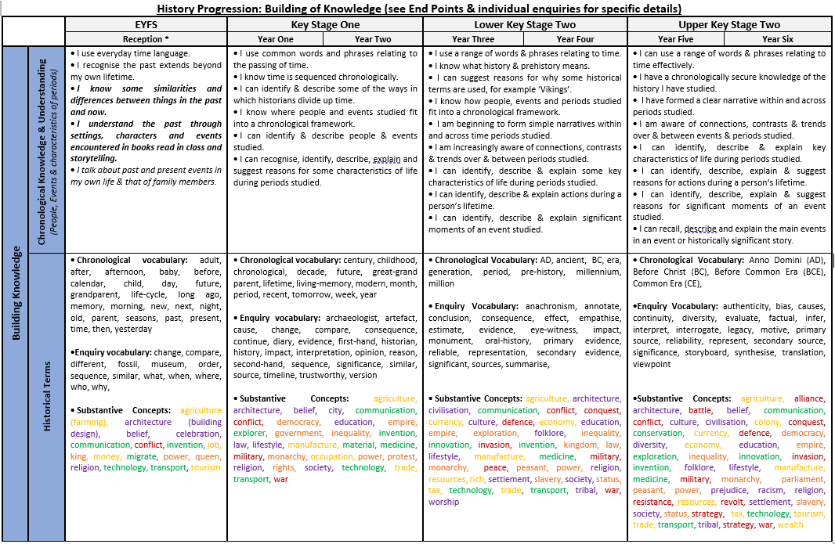
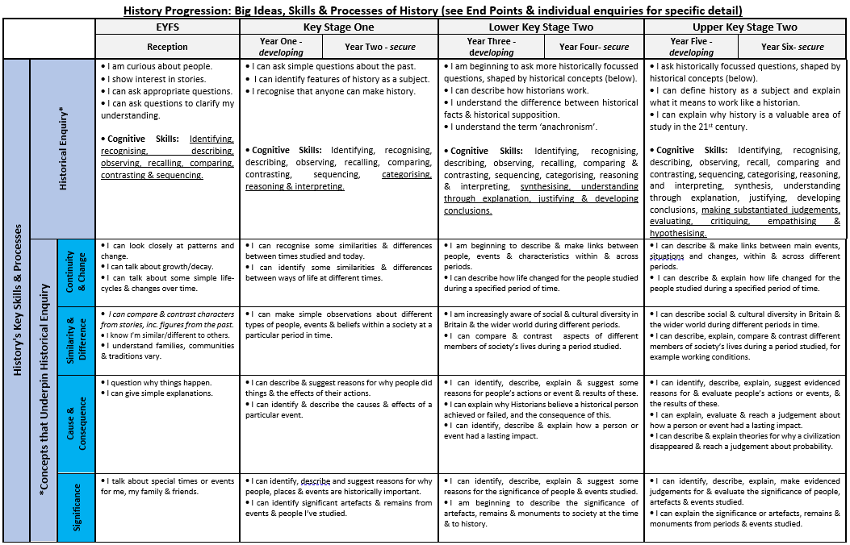
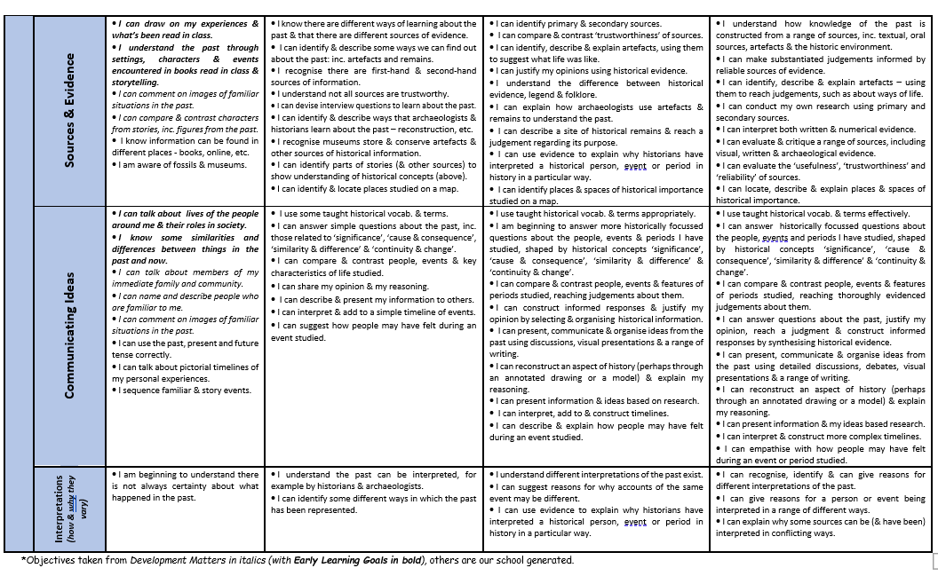
In order to assess impact - a guide
Teachers are responsible for the regular assessment of their pupils against key skills to judge the impact of teaching and learning in History. Teachers look at the learning journey of each unit studied being aware of what the children need for their next learning and what they can take from prior learning. Units will therefore begin with an elicitation task either individual or whole class to judge prior knowledge; a KWL (know want to learn learnt) grid could be used and may be completed independently in books or constructed with the teacher.

Children’s progress is monitored against National Curriculum expectations and key skills. Judgement is informed through use of children’s books dialogue class scrapbooks evidence on Sway and Tapestry and AFL pieces. Teachers need to be clear on how the children will show their learning through a presentation art work or extended writing for example providing opportunity for pupils to communicate their learning in a variety of ways.

There is an expectation that History learning in books will be the same quality as that in English books. Marking and feedback in History should be the same standard as marking/feedback within other learning across the curriculum including English. The focus for spelling corrections is on History vocabulary and the expectation is that children who are ARE will spell these correctly throughout their History writing.

