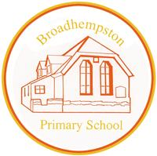
BROADHEMPSTON VILLAGE PRIMARY SCHOOL
SCHOOL LIFE GROUP

Head’s report.
25th Sept 2022

PUPIL NUMBERS - current  R 6  Y1 9  Y2 8  Y3 10  Y4 11  Y5 7  Y6 3  Total 54 | CLASS ORGANISATION  - Birch Class R,Y1&Y2 (Jenny Potter FT & Gaby Cannon )  - Sycamore Class Y3&4 (Sue Cleverley FT)  - Oak Class Y5&6 (Karen Barlow FT)
STAFFING UPDATES
- Mrs Shani Mason has joined us and takes us the position left by Mrs Emma Garner.
- We are in the recruitment process for a full time TA to cover the post Holly Reed has left

SCHOOL IMPROVEMENT PLAN & SCHOOL SELF EVALUATION:
- The key priorities for school have been finalised and I have created our ASIP – which is the school improvement plan which details how we will meet our improvement targets. This is available on our website.

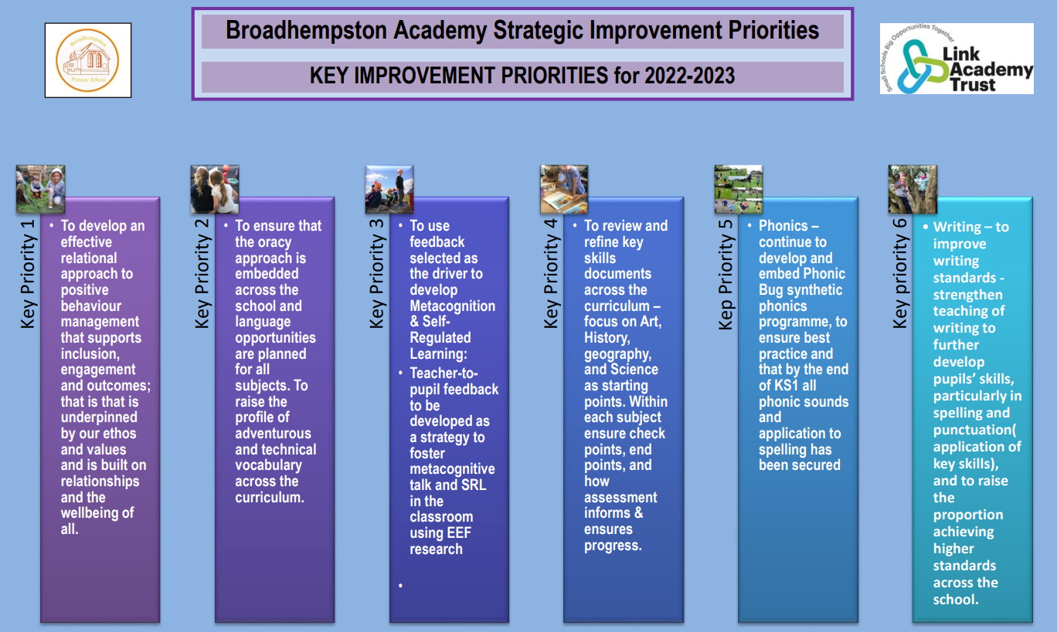

- I have also met with Lizzie Lethbridge& Andy Keay – Academy Trust School Standards & Education Outcomes leads to carry analyse my SEF and hold a Learn, Support & Challenge Day where we completed several deep dives in subjects, monitored teaching and learning, completed a book scrutiny and talked to children. This helps to shape next steps in all areas monitored and prepares staff for Ofsted
HEALTH & SAEFTY/ SAFEGUARDING/ BEHAVIOUR/C19
- All school staff attended Level 2 safeguarding training on Friday 2nd Sept
- All staff have completed Trust H&S training, Prevent training and Cyber Security Training
- Our online Every H&S system is being completed for this term
- Playground equipment in school is due to be tested in the next week

OTHER INFORMATION – VISITORS - COURSES ETC
- Pupil Voice celebrations to be noted: Global neighbours bronze award (awaiting certificate) and Eco School Green Flag award. Sue Cleverley has worked with pupil voice groups to take these projects forward – with very pleasing results.
- New School Council and Eco Group have been voted in by the children. Playleaders will be established this half term and I have also introduced School Ambassadors for Oak Class – these children will be showing new parents around and taking a lead in public events.
- Our Trust Inclusion Hub continues to support school.
- Book fair is booked for 10th Oct
- Arts week will be from 17th Oct – Anna Neville (arts lead for both B&L) has a well-planned week, including visiting artist Sandra Salter from Salty’s studio in Ashburton. Sandra will be developing printing skills with children in each class.
- We will be holding an open evening & exhibition following our arts week on 8th November

Jill Ryder

