**Policy for Relational Behaviour**

**Broadhempston Primary School**

Our core values are central to our school culture and ethos and link directly to our relationships with each other. They have a direct impact on behaviour management at Broadhempston. Used positively they can have a big impact on behaviour management.

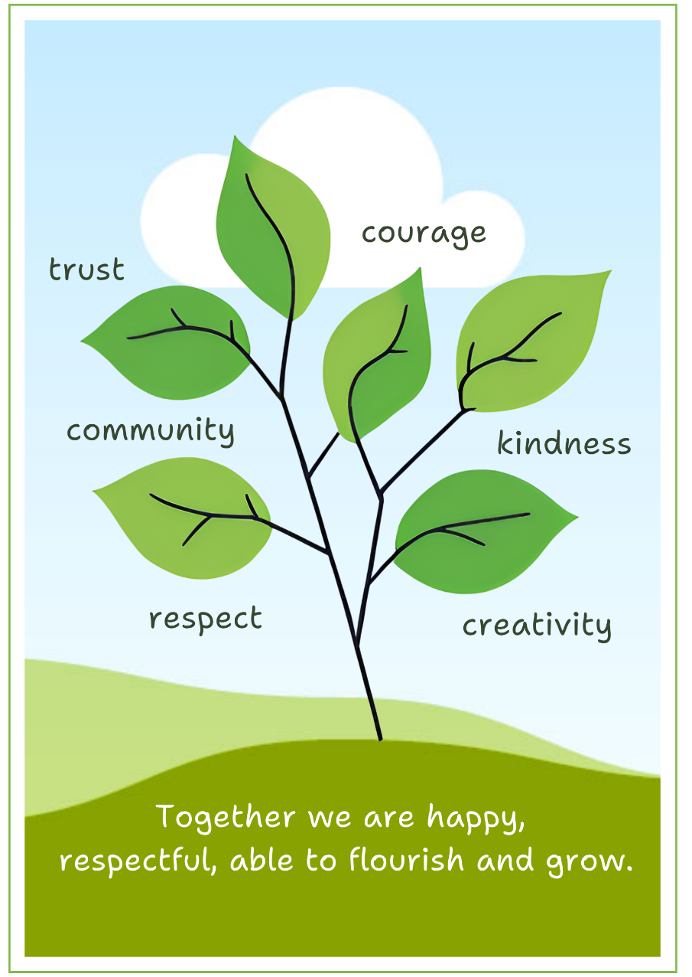

We strive to develop a culture and ethos that will inspire positive behaviour in our school, underpinned by our vison and values. Through our relational behaviour policy, we aim to help children develop the values and principles that will enable them to make a full and positive contribution to our wider community and society. Developing relationships, responding and calming and repairing and restoring are key features of our approach used universally as good quality first teaching and with a focus on our positive whole school ethos that promotes positive relationships and behaviour.

We believe in order to be successful at school all children need to develop secure relationships which enable them to feel safe, secure and good about who they are. Relationships are at the heart of school life.

To promote excellent behaviour, Broadhempston Primary School strives to:

* provide a safe, secure, encouraging and supportive atmosphere where every child is valued
* nurture children towards positive self-confidence and pride as learners, and to help each other to mature socially and emotionally
* encourage children to consciously reflect on their behaviour and empower them to understand that it is within their control to make good choices, including though restorative justice. (In a restorative approach, the inherent worth of each individual is recognised, and we seek to strengthen the essential ties that bind us to one another – in the classroom, school and the community. We encourage children to bravely engage in and learn from honest – and sometimes difficult – conversations.)
* secure an inclusive learning environment and support all individual children under the Equality Act 2010
* teach children to develop positive friendships, using appropriate strategies, including circle time, giving support to individuals and groups as necessary
* enable children to understand what it means to be a good citizen and to put this into practice at school and in the wider community
* develop in children an understanding of and respect for the religious, spiritual, moral and cultural values and views of others, and to thoughtfully consider their own
* encourage children to appreciate our natural environment and understand the importance of conservation

The school community works to maintain:

* a tangible ethos by modelling the living out of our values at all times
* a safe and secure school environment conducive to effective and exciting teaching and learning;
* high expectation of all pupils in all areas of school life including behaviour;
* a fair, consistent, clear and positive approach which involves both high levels of nurture and high levels of expectation around behaviour, with firm boundaries and appropriate actions when agreements are broken;
* a culture of respect between staff, pupils, parents, families and the community as a whole;
* the freedom from physical and verbal abuse in and out of school
* that opportunities and guidance is given so that children can become more responsible for their own behaviour e.g. circle time, peer mediation and a Thrive-style approach

We encourage pupils to:

* encourage all children to live out our values in aspects of their life
* develop responsibility for their own behaviour and reflect on their impact on each other
* develop an understanding of the need for responsible behaviour
* develop respect and tolerance for others
* develop positive attitudes
* develop a co-operative and collaborative mind-set
* develop an effective range of strategies for dealing with problems independently, but seeking support where needed

**SCHOOL AGREEMENTS**

A clear code of acceptable conduct is in operation throughout the school. At the start of each new academic year, each class creates together a class agreement for class and playground, comprising of an agreed set of values and behaviours related to safety, communication, learning and care. This lays the foundations for children to learn to be together.

**REWARDS**

A consistent reward system for positive behaviour is in place throughout the school. Parents will be informed of our celebration of a child’s positive behaviour through certificates and verbal communication, as appropriate.

Rewards are given

* for individual and/or group effort and achievement in learning and behaviour
* for a whole class effort and achievement in learning and behaviour
* for individual or group behaviour and conduct at play times (break and lunch)

Rewards may include

* verbal / non-verbal praise
* stickers
* thank you notes
* certificate for learning (achiever)
* certificate for living out our values (good citizenship)

Celebration assembly occurs on a weekly basis, led by the Head/Senior Teacher to recognise the achievements of the children at an individual, group and class level. In this time, children are presented with certificates to reward living out our values, excellent citizenship and positive attitudes to learning. Pupils may also share home achievements through this celebration assembly. We also award a courtesy cup each week in recognition of a children ‘going over and above’ in living out our values.

**RESTORATIVE PRACTICE**

Restorative practice is a constant feature of our relational work and includes responsive processes for resolving conflict and support children when things go wrong.

If incidents are low level, we have a short restorative discussion with the child will take place in order to assess the situation, re-establish agreements and make it clear what is expected of the child.

Consequences will be applied where pupils continue to break agreements and will depend on the teacher’s professional judgement, knowledge of the child and context.

Sanctions will be issued by members of staff when behaviour is unacceptable, either in school or off school premises, including where it:

* disrupts teaching
* disrupts or stops learning from taking place
* is disrespectful or impolite
* affects the health, safety and well-being of others

Examples of sanctions may include:

* non-verbal warning
* verbal warning
* reflection time in a different space
* withdrawal from an activity
* discussion with the Academy Head
* incidents recorded in a behaviour log
* loss of time at break or lunch to reflect on behaviour or finish work
* parents informed

Our support for a child experiencing prolonged or significant difficulties in managing behaviour may be given through:

* Academy Head involvement
* parental involvement
* individual relation support plans for children
* outside agency involvement, e.g. Early Help, IIH courses, Play therapy…

On rare occasions, it may be necessary to use positive handling strategies to prevent a child hurting themselves, others, or damaging property. Please refer to the Link Academy Trust Positive Handling Policy. Only in extreme cases, it may be necessary to consider a programme of exclusion in line with local authority guidelines.

The school holds that it is essential that all sanctions are fair, consistent and immediate. All sanctions are consistent with our relational approach to behaviour and intrinsically linked to our school ethos and values.

**ANTI-BULLYING POLICY**

**Rationale:**

This policy provides guidance for staff to ensure that the school has a consistent & acceptable approach that supports the bullied & the “bullier”.

A definition of bullying: Bullying is repetitive behaviour designed to hurt or undermine someone else. This can be physical, emotional or mental and can take place face to face or online. It is persistent. It is an action that involves a real or perceived power imbalance.

The following steps may be taken when dealing with incidents. However, all cases need to be judged on their individual merits:

* If bullying is suspected or reported, the incident will be dealt with immediately by the member of staff who has been approached
* A clear account of the incident will be recorded in our BPRI log and the head of school will be informed.
* The head will ‘interview’ all concerned in order to reach an agreed version of events and will record the incident
* All staff will be kept informed so that they are aware of the incident & alerted to further occurrences
* Parents will be kept informed
* Measures will be used as appropriate and in consultation will all parties concerned
* Counselling & the development of social skills & empathy will also be used with all parties as required (Relational support plans and BST, nurture groups, anger management courses,  IIH courses will be used to support such children)

Pupils who have been bullied will be supported by:

* offering an immediate opportunity to discuss the experience with a teacher or member of staff of their choice
* reassuring the pupil
* offering continuous support
* restoring self-esteem and confidence

Pupils who have bullied will be helped by:

* discussing what happened
* discovering why the pupil became involved
* establishing the wrong doing and need to change
* informing parents or carers to help change the attitude of the pupil

The following sanctions can be taken:

* official warnings to cease offending
* lunchtime detentions
* withdrawal from class for a fixed period
* minor fixed-term exclusion
* major fixed-term exclusion
* it is hoped that we will not have to consider permanent exclusion.

Within the curriculum the school will raise the awareness of the nature of bullying through inclusion in PSHE, Anti-bullying week, Safer Internet week and other subject areas, as appropriate, in an attempt to highlight that it is wrong & unacceptable.

**Monitoring, evaluation and review**

The school will review this policy every year and assess its implementation and effectiveness. The policy will be promoted and implemented throughout the school.

Jill Ryder & Broadhempston Team

June 2024