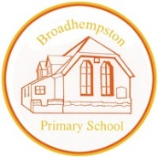
Broadhempston Primary School
Number & Calculation Policy EYFS
Rationale

It is our intent, based on school research and our study as part of the Jurassic Maths Hub, to provide our youngest children with a clear, deep and sense of number. It is our job to lay strong ‘foundations’ for their future mathematical learning, we want them to be excited by numbers and be curious mathematicians.

The 5 Counting Principles (Gelman & Gallistel) underpin the teaching of maths in the EYFS. It is vital that all our children are secure with these principles.

1) The one-one principle: one number name to each object that is being counted.
2) Stable -order principle: when counting numbers have to be said in a certain order.
3) The cardinal principle: number name assigned to the final object is the total number of objects in that group.
4) The abstraction principle: understanding that anything can be counted (not just objects).
5) The order irrelevance principle: the order we count a group of objects is irrelevant.

Number Sense
• Children need to ‘immerse’ themselves in numbers in order to develop a deep ‘number sense’. They need to understand the ‘ness’ of numbers, e.g. what makes six, six? I We spend time learning all about and familiarising ourselves with each number:
• the numeral
• the value (in different representations, both mathematical and non- mathematical)
• representing the number on our fingers
• spotting the number in our environment and where it ‘sits’ in relation to other numbers (place value).
• subitising the number
• composing (and decomposing) the number

This early immersion in number supports the children’s understanding of the place value of numbers, together with early understanding of the concepts of more/less, addition and subtraction. It also supports the development of understanding of mathematical concepts such as part, part, whole when they are introduced later in the year.

Our approach to mathematics is based on the CPA Approach
• Concrete: Concrete is the “doing” stage, using concrete objects to model problems.
• Pictorial: Pictorial is the “seeing” stage, using representations of the objects to model problems.
• Abstract: Abstract is the “symbolic” stage, where children are able to use abstract symbols to model problems.
This approach develops children’s understanding at a deeper level and helps children learn new ideas and build on their existing knowledge by introducing abstract concepts in a more familiar and tangible way.

We use the Developing Matters in the Early Years Foundation Stage (EYFS) as the basis to plan our maths lessons. We pull on other resources, such as WhiteRose. By the end of the reception year children are expected to reach the Early Learning Goal (ELG) outlined below:

Early Learning Goal for Number:
Children at the expected level of development will:
- Have a deep understanding of number to 10, including composition of each number
- Subitise (recognise quantities without counting) up to 5
- Automatically recall (without reference to rhymes, counting or other aids) number bonds up to 5 (including subtraction facts) and some number bonds to 10, including double facts

Early Learning Goal for Numerical Patterns:
Children at the expected level will:
- Verbally count beyond 20, recognising the pattern of the counting system
- Compare quantities up to 10 in different contexts, recognising when one quantity is greater than, less than or the same as the other quantity
- Explore and represent patterns within numbers up to 10, including evens and odds, double facts and how quantities can be distributed equally

Where children make accelerated progress, they are challenged to think deeply, remember, recall and use their skills and knowledge.

Characteristics of Effective Learning: Children are exposed to different representations of mathematical concepts in order to embed their understanding. One of the aims under the Characteristics of Effective Learning is ‘creating and thinking critically.’ Children are encouraged to make links, find new ways to do things, solve problems, change strategies as needed, make predictions and develop and explore ideas of grouping, sequencing, cause and effect. Higher order thinking happens when children are encouraged to seek out challenges and take risks in their learning.

Enabling Environments: We provide a ‘numeracy rich environment’ where there is a balance between both adult led learning and child initiated experiences. Adult led activities should take account of children’s interests and learning styles, maximising the use of the areas of provision,both indoors and outdoors. Careful planning and resourcing is key to the best possible learning outcomes. Many of the planned adult led activities can then be further explored by children (independently) to develop their mathematical skills and consolidate their understanding. Embedding mathematical learning opportunities within daily routines makes it real and purposeful. Number work is ‘threaded’ through our days where there are plenty of opportunities to count for purpose (e.g. register time, snack time), use number rhymes and share stories. It is important that we jump on those ‘spontaneous’ opportunities for learning too,! All staff who work within the EYFS are ‘trained’ to ensure they are able to support and develop the children’s mathematical learning. This process includes: use of the correct vocabulary, terminology, careful questioning, carrying out purposeful observations, being aware of the children’s next steps.

Vocabulary:

• Explicit teaching and use of key vocab is crucial, including visual displays on maths wall and in other areas of provision.
• Key child friendly phrases are used, such as ‘careful counting’, ‘cup of tea numbers’ (when learning to count in 10s later in the year).
• STEM sentences modelled and reinforced with actions.
• Misconceptions are identified and addressed (individually and as a whole group).
• Opportunities for children to use language and vocabulary in their chosen provision activities are provided/developed through careful observations, and where appropriate with questioning.

Number & counting
Key representations of number that will be used: EG 1-5 (similarly for 5-10)

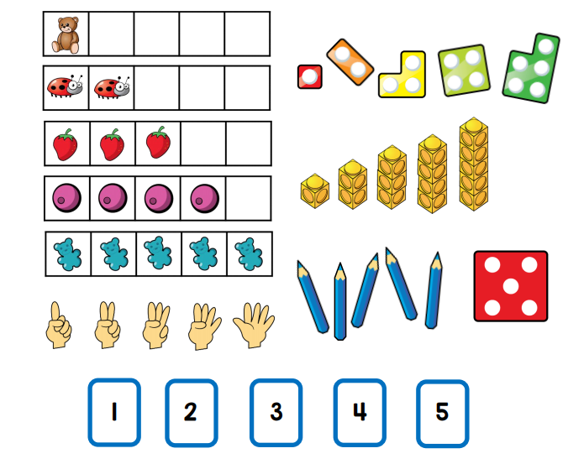

Addition: Images that may be used | Notes
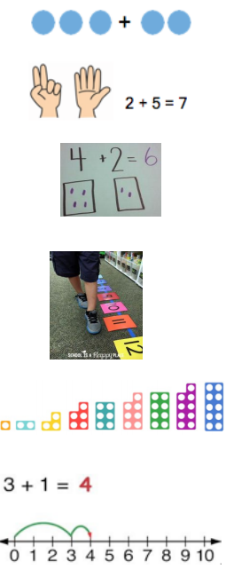 | - Children begin to combine groups of objects or pictures using concrete appar  - Solve simple problems using fingers.  - Construct number sentences verbally or using cards to go with practical activities.  - Children are encouraged to read number sentences aloud in different ways e.g. “Three add two equals 5” “5 is equal to three and  - two.”  - Count on to find the answer.  - Have an understanding of what “more” means and be able to say what is one more than a given number.  - Number tracks can be introduced to count up on and to find one more.  - Children make a record in pictures, words or symbols of addition activities.  - When appropriate, Numicon shapes are introduced to identify 1 more/less, combine pieces to add and find number bonds.  - Number lines can be used alongside number tracks and practical apparatus to solve addition calculations and word problems.  VOCABULARY:  Add, more than, sum, and make, total, altogether.
Subtraction images that may be used | Notes
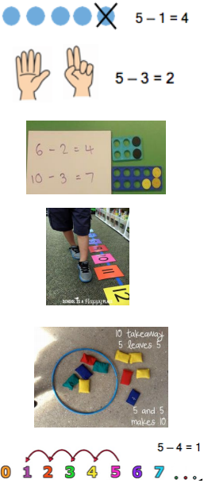 | - Concrete apparatus is used to relate subtraction to taking away and counting how many objects are left.  - Solve simple problems using fingers.  - Construct number sentences verbally or using cards to go with practical activities.  - Children are encouraged to read sentences aloud in different ways “five subtract one leaves four” “four is equal to five subtract one.”  - Count back to find the answer.  - Have an understanding of what “less” means and be able to say what is one less than a given number. What is 1 less than 9? 1 less than 20?  - Number tracks can be introduced to count back and to find one less.  - Children make a record in pictures, words or symbols of subtraction activities.  - Number lines can then be used alongside number tracks and practical apparatus to solve subtraction calculations and word problems.  VOCABULARY  Take (away), leave, left/left over, less, fewer, difference.
Multiplication images that may be used | Notes
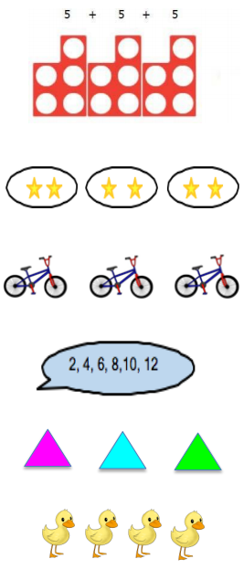 | - The link between addition and multiplication can be introduced through doubling and reinforced through repeated addition of the same number.  - Numicon is used to visualise the repeated adding of the same number.  - Children begin with mostly pictorial representations e.g. How many groups of 2 are there? 2 + 2 + 2 + 2 + 2, so 5 groups of 2.  - Real life contexts and use of practical equipment is used to count in repeated groups of the same size e.g. How many wheels are there altogether?  - Children are encouraged to read number sentences aloud in different ways “five times two makes ten” “ten is equal to five multiplied by two” “ten is the same as five lots of two.”  - Count in twos, fives and tens both aloud and with objects.  - Children are given multiplication problems set in a real life context. Children are encouraged to visualise the problem e.g. How many fingers on two hands? How many sides on three triangles?  VOCABULARY  Lots of, groups of, repeated addition, double, combine, times.
Division & Fractions images that may be used | Notes
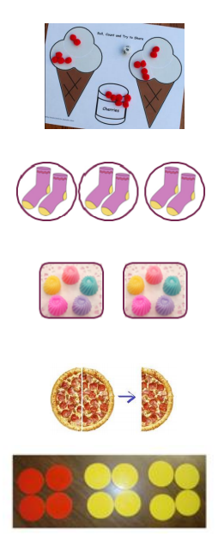 | - Division can be introduced through halving or sharing an equal amount into 2 groups.  - Children begin with mostly pictorial representations linked to real life contexts.  - Children need to see and hear representations of division as both grouping and sharing.  Grouping model:  - Mum has 6 socks. She grouped them into pairs. How many pairs did she make?  Sharing model:  - I have 10 sweets. I want to share them with my friend. How many will we have each? The sharing model is a useful way to introduce young children to fractions e.g. Can you cut the pizza in half?  - Children make a record in pictures, words or symbols of division activities.  - Children are encouraged to have a go at recording the calculation that has been carried out e.g. by arranging concrete objects into groups.  VOCABULARY  Half, halve, share, equal, groups of, left/left over

