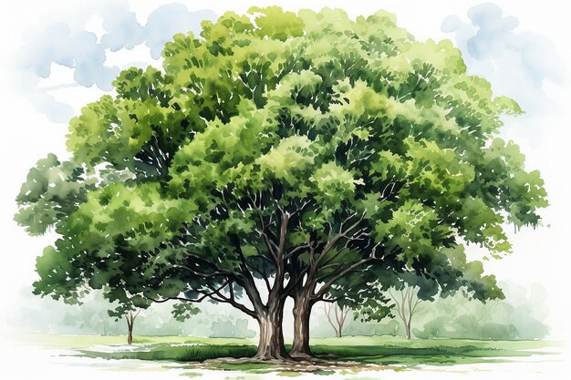

Science: Living things and their habitats: Life cycles / Living things and their habitats: Classification

Spanish: School Life / Trip Across Spain

Computing: Selection in physical computing/ Variables in games

History: How did the ancient Maya change their way of life?

RE / World Views: How can following God bring freedom and justice?

How does faith help people when life gets hard?

Art: Gargoyles (sculpture)

Music: Traditional music (South and West Africa) / Drumming

DT: Bridges (structures)

Geography: Why is fair trade fair?

PSHE: Relationships/ Changing Me