Broadhempston Village Primary School:
Number & Calculation policy: Years 5&6

Intent

At Broadhempston our intent is based on school research as part of The Link Academy Maths Hub, to enable KS2 children to develop the core ideas that underpin all calculation. In Years 5 & 6 children will continue to develop fluency, accuracy and an ability to select appropriate and efficient methods when using the four operations: + / - / X / ÷. Children in these year groups will work with whole numbers and decimals; applying skills to problem solving, reasoning their choices with confidence.

Staff will begin units of work with an elicitation task/pre assessment in order to ascertain prior understanding and future steps. These pre-assessments will include questions involving fluency, reasoning and problem solving, in a variety of contexts. These tasks will provide staff with a clear picture of children’s knowledge and skills and then allow staff to meet need and extend children’s learning from their individual starting points. They will be used again at the end of a unit of work, enabling staff to see a clear picture of progress and mastery of given areas.

Threaded through all learning across the school we use CAPED to enable children to demonstrate their mastery of mathematics:
C: check it
A: another way
P: prove it
E: explain
D: draw

Key Vocabulary:
round, decimal, column methods, exchange, partition, mental method, ten thousand, hundred thousand, million, factor, multiple, prime number, square number, cube number

Years 5&6
 | Concrete | Pictorial | Abstract
Place value
Multiplying by 10, 100 and 1,000 | Use place value equipment to multiply by 10, 100 and 1,000 by unitising.  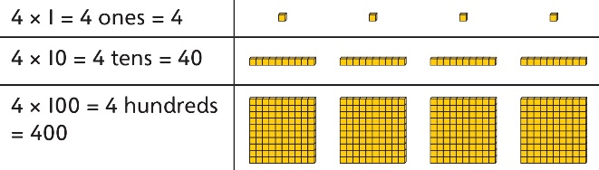 | Understand the effect of repeated multiplication by 10.  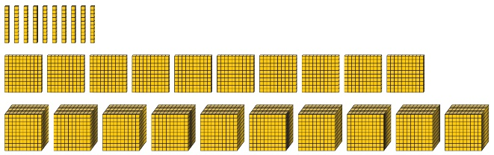 | Understand how exchange relates to the digits when multiplying by 10, 100 and 1,000.  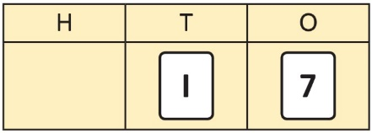  17 × 10 = 170  17 × 100 = 17 × 10 × 10 = 1,700  17 × 1,000 = 17 × 10 × 10 × 10 = 17,000
Multiplying decimals by 10, 100 and 1,000 | Use place value equipment to explore and understand the exchange of 10 tenths, 10 hundredths or 10 thousandths. | Represent multiplication by 10 as exchange on a place value grid.  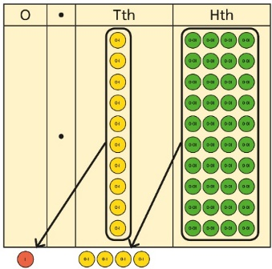  0·14 × 10 = 1·4 | Understand how this exchange is represented on a place value chart.  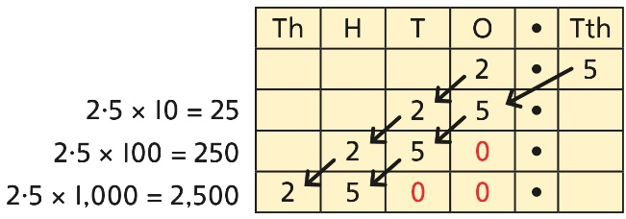
Multiplying by 10, 100 and 1,000 | Use place value equipment to explore exchange in decimal multiplication.  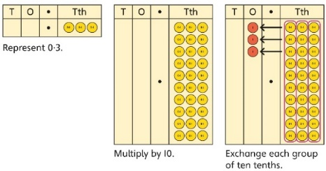  0·3 × 10 = ?  0·3 is 3 tenths.  10 × 3 tenths are 30 tenths.  30 tenths are equivalent to 3 ones. | Understand how the exchange affects decimal numbers on a place value grid.  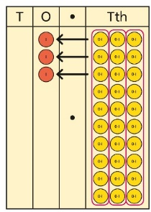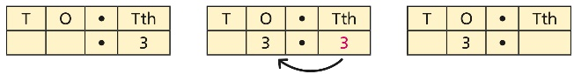  0·3 × 10 = 3 | Use knowledge of multiplying by 10, 100 and 1,000 to multiply by multiples of 10, 100 and 1,000.  8 × 100 = 800  8 × 300 = 800 × 3  = 2,400  2·5 × 10 = 25  2·5 × 20 = 2·5 × 10 × 2  = 50
Dividing whole numbers by 10, 100 and 1,000 | Use place value equipment to support unitising for division.  4,000 ÷ 1,000  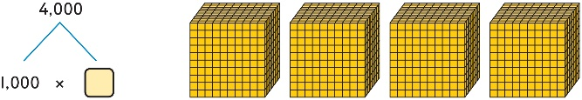  4,000 is 4 thousands.  4 × 1,000= 4,000  So, 4,000 ÷ 1,000 = 4 | Use a bar model to support dividing by unitising.  380 ÷ 10 = 38  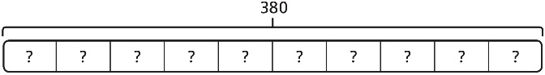  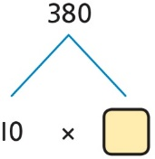  380 is 38 tens.  38 × 10 = 380  10 × 38 = 380  So, 380 ÷ 10 = 38 | Understand how and why the digits change on a place value grid when dividing by 10, 100 or 1,000.  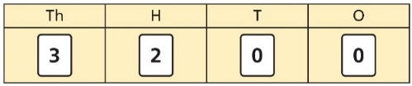  3,200 ÷ 100 = ?  3,200 is 3 thousands and 2 hundreds.  200 ÷ 100 = 2  3,000 ÷ 100 = 30  3,200 ÷ 100 = 32  So, the digits will move two places to the right.
Dividing by multiples of 10, 100 and 1,000 | Use place value equipment to represent known facts and unitising.  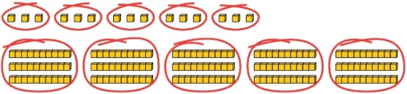  15 ones put into groups of 3 ones. There are 5 groups.  15 ÷ 3 = 5  15 tens put into groups of 3 tens. There are 5 groups.  150 ÷ 30 = 5 | Represent related facts with place value equipment when dividing by unitising.  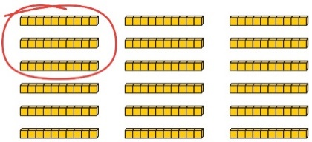  180 is 18 tens.  18 tens divided into groups of 3 tens. There are 6 groups.  180 ÷ 30 = 6  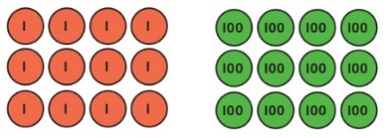  12 ones divided into groups of 4. There are 3 groups.  12 hundreds divided into groups of 4 hundreds. There are 3 groups.  1200 ÷ 400 = 3 | Reason from known facts, based on understanding of unitising. Use knowledge of the inverse relationship to check.  3,000 ÷ 5 = 600  3,000 ÷ 50 = 60  3,000 ÷ 500 = 6  5 × 600 = 3,000  50 × 60 = 3,000  500 × 6 = 3,000  Use knowledge of factors to divide by multiples of 10, 100 and 1,000.  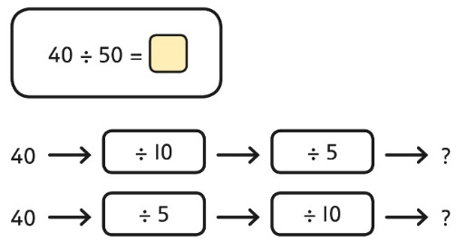  40 ÷ 5 = 8  8 ÷ 10 = 0·8  So, 40 ÷ 50 = 0·8
Dividing decimals by 10, 100 and 1,000 | Understand division by 10 using exchange.  2 ones are 20 tenths.  20 tenths divided by 10 is 2 tenths.  Use place value equipment to explore division as exchange.  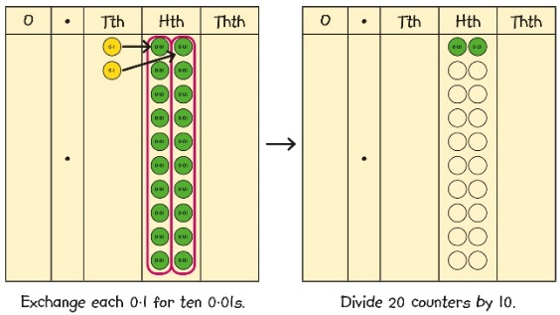  0·2 is 2 tenths.  2 tenths is equivalent to 20 hundredths.  20 hundredths divided by 10 is 2 hundredths. | Represent division using exchange on a place value grid.  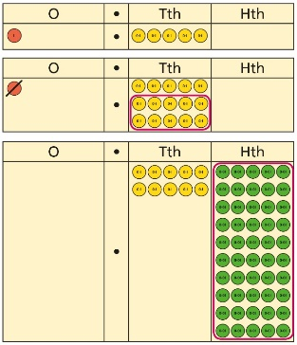  1·5 is 1 one and 5 tenths.  This is equivalent to 10 tenths and 50 hundredths.  10 tenths divided by 10 is 1 tenth.  50 hundredths divided by 10 is 5 hundredths.  1·5 divided by 10 is 1 tenth and 5 hundredths.  1·5 ÷ 10 = 0.15 | Understand the movement of digits on a place value grid.  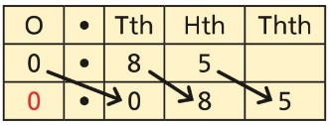  0·85 ÷ 10 = 0·085  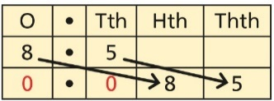  8·5 ÷ 100 = 0·085
Round to the nearest 10 / 100 / 1000 /  10,000 | 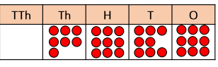  use place value chart to round to the nearest 100, 1000, 10,000 | 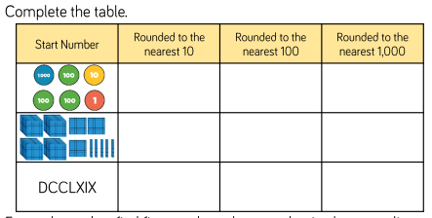  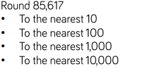 | Round to the nearest 10 / 100 / 1000 /  10,000
Addition | All children will be taught: column addition  Place value equipment will be used to represent additions and support mathematics where necessary
Column addition with whole numbers  Y6: Comparing and selecting efficient methods  Adding decimals using column addition  Y6: Comparing and selecting efficient methods | Use place value equipment to represent additions.  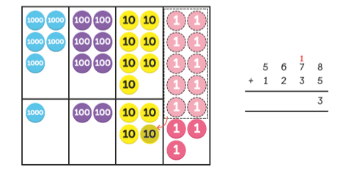 | Represent additions, using place value equipment on a place value grid alongside written methods.  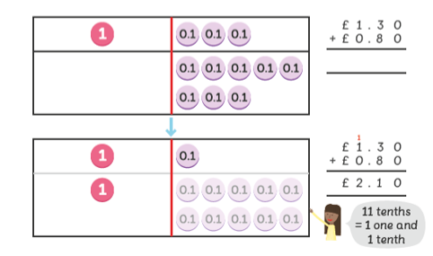 | Use column addition, including exchanges.  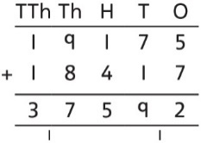Add using a column method, ensuring that children understand the link with place value.  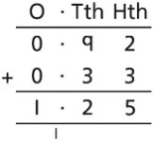  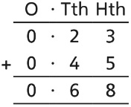  Include exchange where required, alongside an understanding of place value.  Include additions where the numbers of decimal places are different.  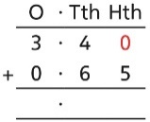 3.4 + 0.65 = ?
Selecting mental methods for larger numbers where appropriate | Represent 7-digit numbers on a place value grid, and use this to support thinking and mental methods.  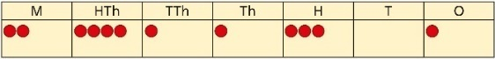  2,411,301 + 500,000 = ?  This would be 5 more counters in the HTh place.  So, the total is 2,911,301.  2,411,301 + 500,000 = 2,911,301 | Use a bar model to support thinking in addition problems.  257,000 + 99,000 = ?  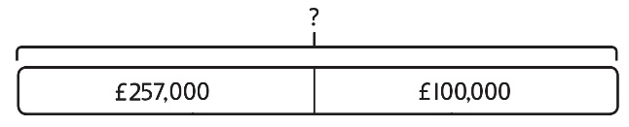  I added 100 thousands then subtracted  1 thousand.  257 thousands + 100 thousands = 357 thousands  257,000 + 100,000 = 357,000  357,000 – 1,000 = 356,000  So, 257,000 + 99,000 = 356,000 | Use place value and unitising to support mental calculations with larger numbers.  195,000 + 6,000 = ?  195 + 5 + 1 = 201  195 thousands + 6 thousands = 201 thousands  So, 195,000 + 6,000 = 201,000
Understanding order of operations in calculations | Use equipment to model different interpretations of a calculation with more than one operation. Explore different results.  3 × 5 − 2 = ?  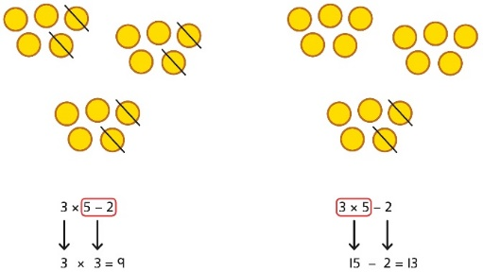 | Model calculations using a bar model to demonstrate the correct order of operations in multi-step calculations.  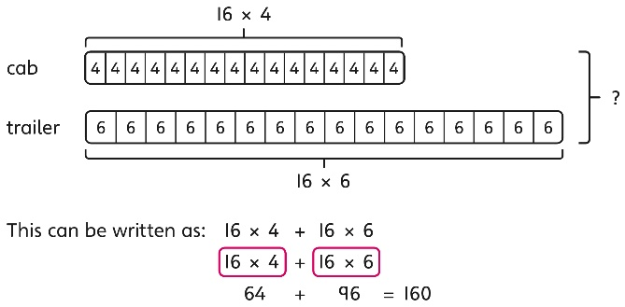 | Understand the correct order of operations in calculations without brackets.  Understand how brackets affect the order of operations in a calculation.  4 + 6 × 16  4 + 96 = 100  (4 + 6) × 16  10 × 16 = 160
Other representations and methods may include:
Representing additions |  | Bar models represent addition of two or more numbers in the context of problem solving.  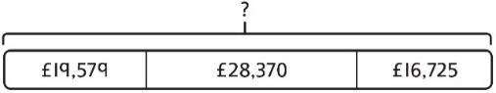  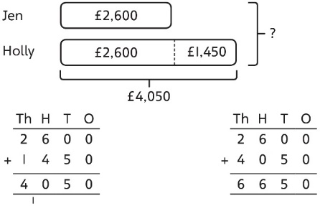 | Use approximation to check whether answers are reasonable.  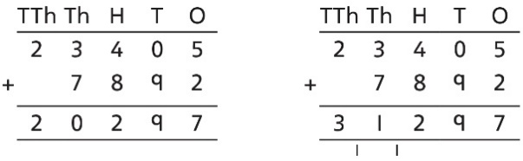  I will use 23,000 + 8,000 to check.
Adding tenths | Link measure with addition of decimals.  Two lengths of fencing are 0·6 m and  0·2 m.  How long are they when added together? | Use a bar model with a number line to add tenths.  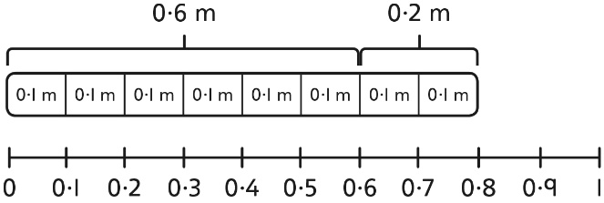  0·6 + 0·2 = 0·8  6 tenths + 2 tenths = 8 tenths | Understand the link with adding fractions.  $$\frac{6}{10}+\frac{2}{10}=\frac{8}{10}$$  6 tenths + 2 tenths = 8 tenths  0·6 + 0·2 = 0·8
Subtraction | All children will be taught: column subtraction
 | Concrete | Pictorial | Abstract
Column subtraction with whole numbers  By Y6: Comparing and selecting efficient methods | By Y6 compare subtraction methods alongside place value representations.  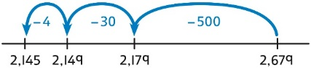  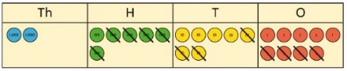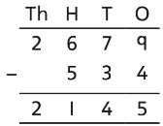  Use a bar model to represent calculations, including ‘find the difference’ with two bars as comparison.  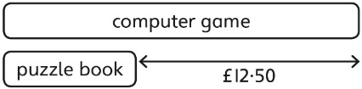 |  | Use column subtraction methods with exchange where required.  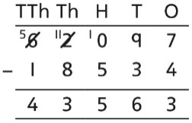  62,097 − 18,534 = 43,563
Subtracting decimals | 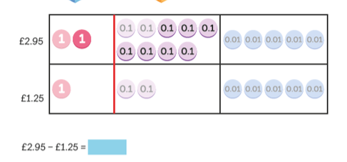 |  | Use column subtraction, with an understanding of place value, including subtracting numbers with different numbers of decimal places.  3·921 − 3·75 = ?  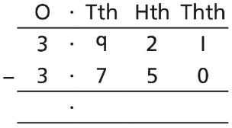
Subtracting mentally with larger numbers | Use a bar model to show how unitising can support mental calculations.  950,000 − 150,000  That is 950 thousands − 150 thousands  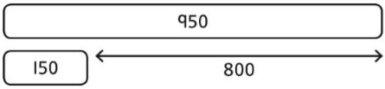  So, the difference is 800 thousands.  950,000 − 150,000 = 800,000 |  | Subtract efficiently from powers of 10.  10,000 − 500 = ?
Other representations and methods may include:
Checking strategies and representing subtractions | Bar models represent subtractions in problem contexts, including ‘find the difference’.  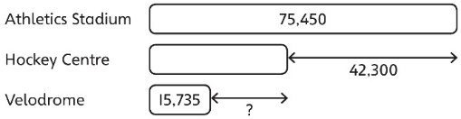 |  | Children can explain the mistake made when the columns have not been ordered correctly.  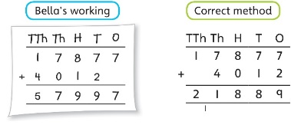  Use approximation to check calculations.  I calculated 18,000 + 4,000 mentally to check my subtraction.
Choosing efficient methods | To subtract two large numbers that are close, children find the difference by counting on.  2,002 − 1,995 = ?  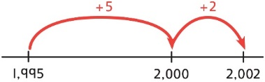  Use addition to check subtractions.  I calculated 7,546 − 2,355 = 5,191.  I will check using the inverse.
Multiplication | By year 5: All children should know or learn all multiplication facts to 12x12. Where they don’t this will be taught and given as home learning.
All children will be taught: short and long multiplication methods
Multiplying up to 4-digit numbers by a single digit | By Y6 use place value & equipment to compare methods  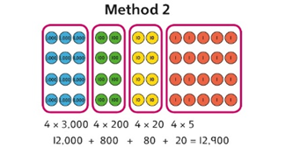  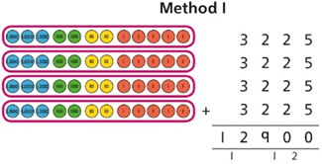 |  | Use an area model and then add the parts.  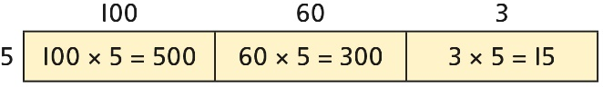  Use a column multiplication, including any required exchanges.  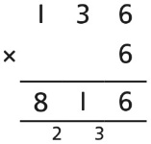  By Y6 use efficient strategies
Multiplying 2-digit numbers by 2-digit numbers | Use column multiplication, ensuring understanding of place value at each stage.  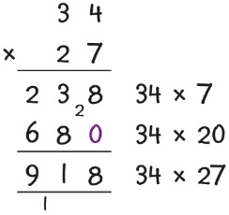  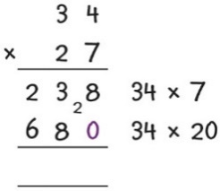  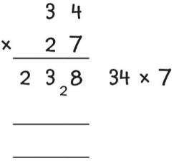
Multiplying up to 4-digits by 2-digits | Use column multiplication, ensuring understanding of place value at each stage.  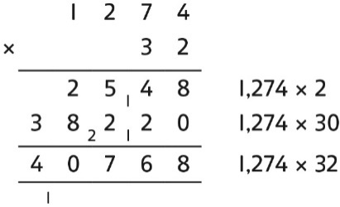  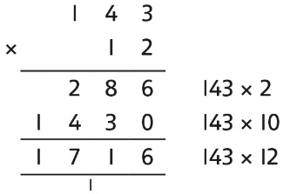 1,274 × 32 = 40,768
Multiplying decimals | Use known facts to multiply decimals.  4 × 3 = 12  4 × 0·3 = 1·2  4 × 0·03 = 0·12  20 × 5 = 100  20 × 0·5 = 10  20 × 0·05 = 1  Find families of facts from a known multiplication.  I know that 18 × 4 = 72.  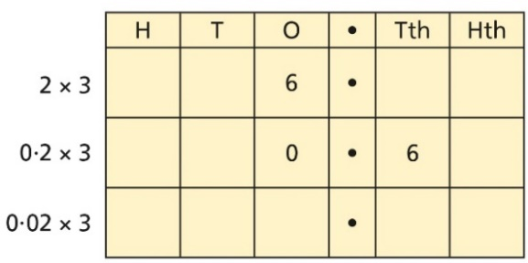  This can help me work out:  1·8 × 4 = ?  18 × 0·4 = ?  180 × 0·4 = ?  18 × 0·04 = ?  Use a place value grid to understand the effects of multiplying decimals.
Other representations and methods may include:
Understanding factors | Use Cuisenaire, cubes or counters to explore the meaning of ‘square numbers’.  25 is a square number because it is made from 5 rows of 5.  Use cubes to explore cube numbers.  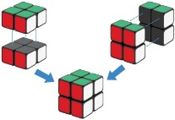  8 is a cube number. | Use images to explore examples and non-examples of square numbers.  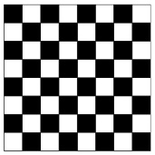  8 × 8 = 64  8² = 64 | Understand the pattern of square numbers in the multiplication tables.  Use a multiplication grid to circle each square number. Can children spot a pattern?  Use a known fact to generate families of related facts.  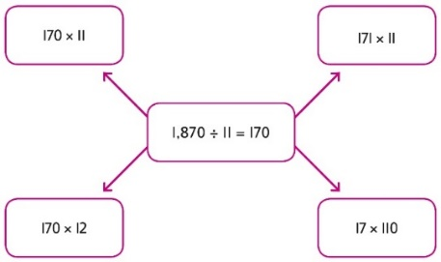  Use factors to calculate efficiently.  15 × 16  = 3 × 5 × 2 × 8  = 3 × 8 × 2 × 5  = 24 × 10  = 240
Understanding factors | Use equipment to explore different factors of a number.  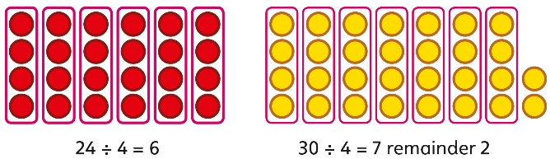  4 is a factor of 24 but is not a factor of 30. | Recognise prime numbers as numbers having exactly two factors. Understand the link with division and remainders.  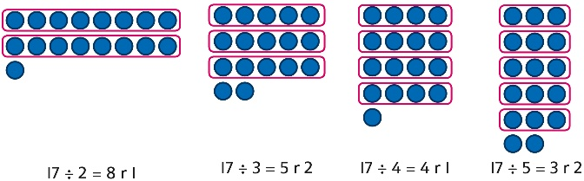 | Recognise and know primes up to 100.  Understand that 2 is the only even prime, and that 1 is not a prime number.  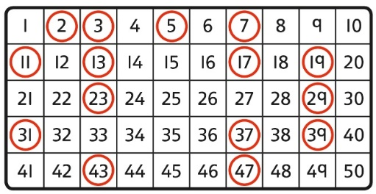
Division | All children will be taught: short and long division methods
Dividing up to four digits by a single digit using short division  Dividing decimals  Understanding inverse operations and the link with multiplication & division | Explore grouping using place value equipment.  268 ÷ 2 = ?  There is 1 group of 2 hundreds.  There are 3 groups of 2 tens.  There are 4 groups of 2 ones.  264 ÷ 2 = 134 | Use place value equipment on a place value grid alongside short division.  The model uses grouping.  A sharing model can also be used, although the model would need adapting.  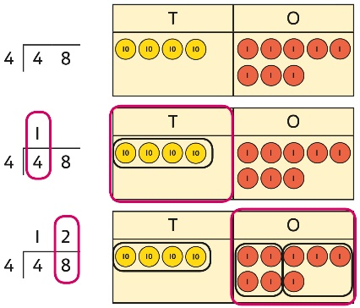  Lay out the problem as a short division.  There is 1 group of 4 in 4 tens.  There are 2 groups of 4 in 8 ones.  Work with divisions that require exchange.  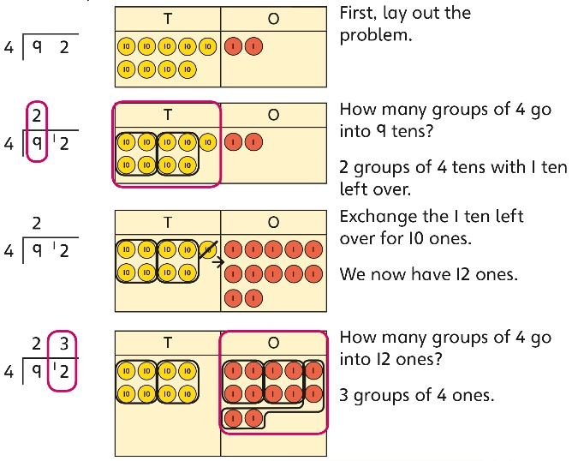 | Use short division for up to 4-digit numbers divided by a single digit.  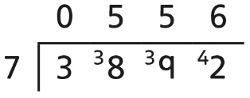  3,892 ÷ 7 = 556  Use multiplication to check.  556 × 7 = ?  6 × 7 = 42  50 × 7 = 350  500 × 7 = 3500  3,500 + 350 + 42 = 3,892  Use short division to divide decimals with up to 2 decimal places.  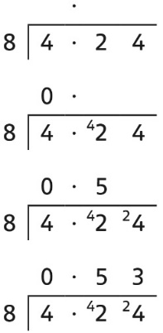
Understanding remainders | Understand remainders using concrete versions of a problem.  80 cakes divided into trays of 6.  80 cakes in total. They make 13 groups of 6, with 2 remaining. | Use short division and understand remainders as the last remaining 1s.  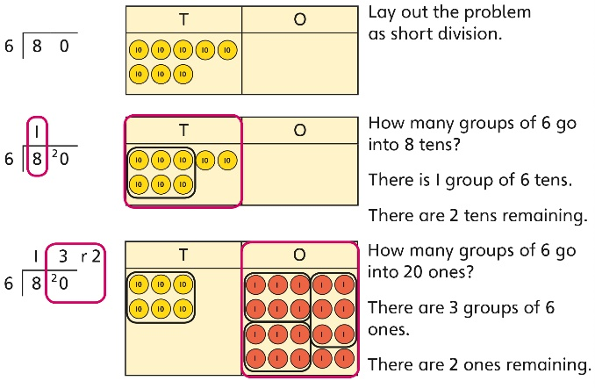 | In problem solving contexts, represent divisions including remainders with a bar model.  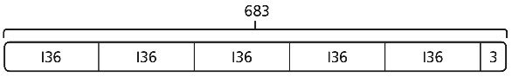  683 = 136 × 5 + 3  683 ÷ 5 = 136 r 3
Dividing by a 2-digit number using long division  Understanding inverse operations and the link with multiplication & division | Use equipment to build numbers from groups.  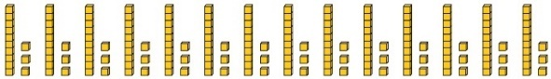  182 divided into groups of 13.  There are 14 groups. | Use an area model alongside written division to model the process.  377 ÷ 13 = ?  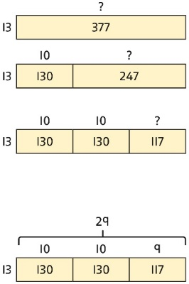  377 ÷ 13 = 29 | Use long division where factors are not useful (for example, when dividing by a  2-digit prime number).  Write the required multiples to support the division process.  377 ÷ 13 = ?  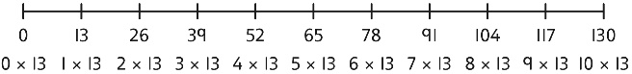  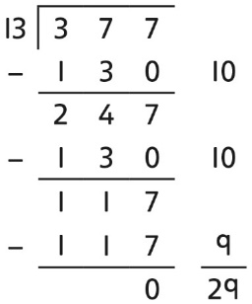  377 ÷ 13 = 29  A slightly different layout may be used, with the division completed above rather than at the side.  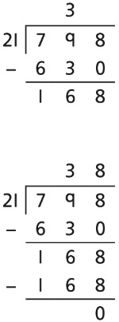  Divisions with a remainder explored in problem-solving contexts.
Other representations and methods may include:
Understanding the relationship between fractions and division | Use sharing to explore the link between fractions and division.  1 whole shared between 3 people.  Each person receives one-third.  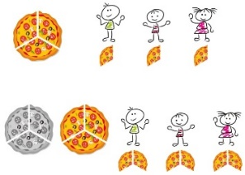 | Use a bar model and other fraction representations to show the link between fractions and division.  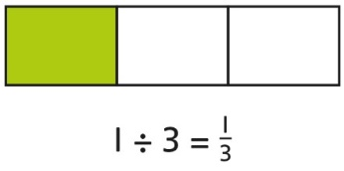 | Use the link between division and fractions to calculate divisions.  $$5÷4=\frac{5}{4}=1\frac{1}{4}$$  $$11 ÷4=\frac{11}{4}=2\frac{3}{4}$$
Dividing by a 2-digit number using factors | Understand that division by factors can be used when dividing by a number that is not prime. | Use factors and repeated division.  1,260 ÷ 14 = ?  1,260 ÷ 2 = 630  630 ÷ 7 = 90  1,260 ÷ 14 = 90 | Use factors and repeated division where appropriate.  2,100 ÷ 12 = ?  