Ofsted review of sexual abuse in schools and colleges _ Broadhempston response

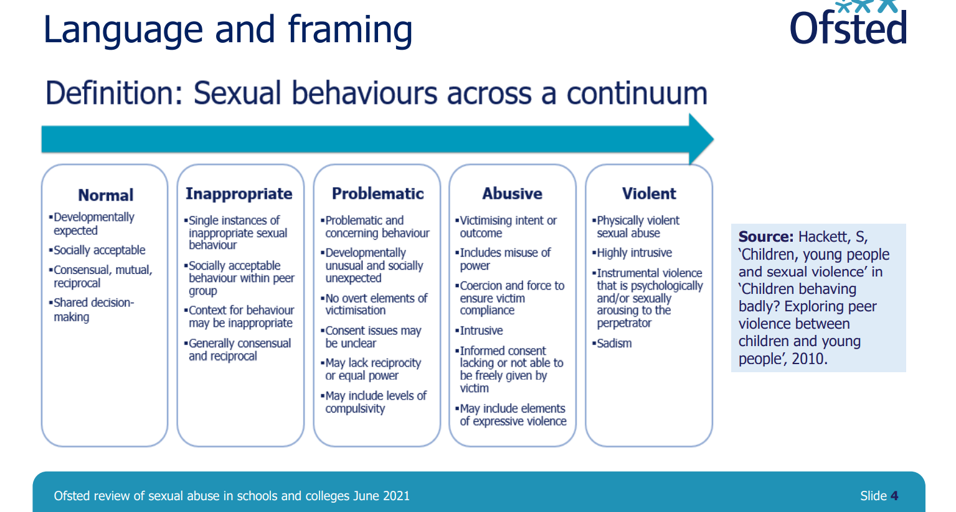

What does this look like in our school?
- School has a culture free from sexual harassment . Trusting relationships exist.
- Children are enabled to develop the vocabulary and confidence needed to clearly articulate their thoughts and feelings in a climate of openness, trust and respect, and know when and how they can seek the support of others. They will apply their understanding of society to their everyday interactions, from the classroom to the wider community of which they are a part.
- Brook tool supports us to identify normal, healthy developmental sexual behaviours
- Inappropriate behaviours may include simple show me your & I’ll show you mine games. At EYFS & early KS1 this would be developmentally healthy, but discussion would take place around appropriate behaviour in school.
- As small school we know our children and families well. Changes in behaviour are easily spotted, conversations in our open and trusting environment allow for rapid and appropriate responses to be made by the adults to ensure safety of all
- We are aware of our families where there are older siblings who may use bad language and say inappropriate things. If children at Broadhempston said such things staff would sensitively challenge to discuss appropriateness
- Some children may have access to the internet / gaming (particularly with older siblings). Any signs or conversations children have with us would result in a quick response and staff would discuss with parents
- NSPCC & CAP are booked to ensure we empower children to be "Safe, Strong, and Free".
- Parent workshops are also run by CAP & NSPCC

HOME | cap-project (childassaultprevention.org)

Talk PANTS & Join Pantosaurus - The Underwear Rule | NSPCC

PSHE CURRICULUM PLAN:
Changing Me: Jigsaw
All year groups have opportunities to discuss changes and any concerns or worries they may have around changes/puberty.

Ages 5-6
- Know which parts of the body are private and that they belong to that person and that nobody has the right to hurt these
- Know who to ask for help if they are worried or frightened

Questions for family learning:
• Which parts of your body are private?
• Who is allowed to see your private body parts?
• What should you do if you don’t like the way someone is touching you?
• Who can you talk to if you ever feel worried or frightened? (at school / at home)

Ages 6-7: same as above + additional points below
- Know there are different types of touch and that some are acceptable and some are unacceptable
- Can say what types of touch they find comfortable/ uncomfortable
- Be able to confidently ask someone to stop if they are being hurt or frightened

Questions for family learning are similar to above

Ages 10-11
- Understand that mutual respect is essential in a boyfriend / girlfriend relationship and that they shouldn’t feel pressured into doing something that they don’t want to

Questions for family learning:
• What does mutual respect mean? Why is that important in a relationship?

Relationships: Jigsaw

Ages 5-6
- Know the characteristics of healthy and safe friends
- Know about the different people in the school community and how they help
- Can say no when they receive a touch they don’t like

Questions for family learning:
• Who do you / don’t you hug?
• Who can you ask for help at school? (In the class, in the playground, in the hall)

Ages 6-7
- Know how to stay stop if someone is hurting them
- Can recognise and talk about the types of physical contact that is acceptable or unacceptable
- Can identify who they trust in their own relationships
- Can say who they would go to for help if they feel scared or worried
Questions for family learning:
•What would you do if someone was hurting you at school?
• Who would you go to for help at school?

Ages 7-8
- Know some strategies for keeping themselves safe online
- Know how some of the actions and work of people around the world help and influence my life
- Know that they and all children have rights (UNCRC)
- Know how to access help if they are concerned about anything on social media or the internet

Questions for family learning:
• How can you stay safe online? What should our rules be?
• What would you do if you saw or heard something online that made you feel worried?
• What rights do children have?

Ages 8-9
- Know that sometimes it is better for a friendship/ relationship to end if it is causing negative feelings or is unsafe

Ages 9-10
- Know that belonging to an online community can have positive and negative consequences
- Know that there are rights and responsibilities in an online community or social network
- Know that there are rights and responsibilities when playing a game online
- Know how to stay safe when using technology to communicate with friends

Questions for family learning:
•What online games do you like to play? Who do you play them with?
• Do you ever talk to people you don’t know online?
• How do you know if people you talk to online are really who they say they are?
• What would you do if you saw or heard something online that made you feel uncomfortable

Ages 10-11
- Know that sometimes people can try to gain power or control them
- Know some of the dangers of being ‘online’
- Know how to use technology safely and positively to communicate with their friends and family
- Can resist pressure to do something online that might hurt themselves or others
- Can take responsibility for their own safety and well-being

Questions for family learning:
•Who do you talk to online?
•What would you do if they said something that you didn’t like?

